## 

**SOFTWARE REQUIREMENT SPECIFICATION**

**For**

**Rate Management**

**Kandy MC**

*Version 1.4*

**Document Acceptance**

|  |  |
| --- | --- |
| Deliverable | Software Requirement Specification- Rate Management Service |
| Deliverable Date |  |
| Client | Kandy Municipal Council |

|  |  |  |  |
| --- | --- | --- | --- |
| Version | Date | Author | Reviewer |
| Version 1.1 | 18/11/2022 | M.M.H.R.Ruwanthi |  |
| Version 1.2 | 23/11/2022 | M.M.H.Ruwanthi |  |
| Version 1.3 | 15/03/2023 | M.M.H.Ruwanthi |  |
| Version 1.4 | 22/03/2023 | M.M.H.Ruwanthi |  |

Document Amendment Register

Table of Contents

1

RATE MANAGEMENT 8

1. PROPERTY MASTER DATA 8

**1.1.** **Property type management** 8

**1.2.** **Divisions Management** 9

**1.3.** **Streets Management** 9

2. NEW ASSESSMENT FEATURE 10

**2.1.** **Add for new property** 10

2.1.1. Add new Property details 10

2.1.2. Add Owner details for the property 11

**2.2.** **Add new property for a future quarter** 16

3. PROPERTY SEARCH 17

4. VIEW PREMISES FEATURE 18

**4.1.** **View Payment history** 19

**4.2.** **View Inquiry Report** 19

**4.3.** **View property change history** 20

**4.4.** **Disable or Enable Property.** 21

**4.5.** **Remove Property** 22

**4.6.** **Print notice of assessment (KFORM)** 23

**4.7.** **Add Notes** 23

**4.8.** **View Notes** 24

**4.9.** **View Created User Details** 24

**4.10.** **Previous Approval Details** 25

**4.11.** **Block** 25

5. EDIT ASSESSMENT FEATURE 25

**5.1.** **Change all property details** 25

**5.2.** **Setup for edit option for the approval status** 27

**5.3.** **Property of Non resident** 27

6. QUARTER CALCULATION FEATURE 28

7. RATES PAYMENT FEATURE 29

**7.1.** **Auto discount calculation.** 30

**7.2.** **Ability to pay any amount** 30

**7.3.** **Payment between Branches** 30

**7.4.** **Check Online Receive Payment** 31

**7.5.** **Multiple Property Payment** 31

**7.6.** **Payment for Upcoming year tax** 33

**7.7.** **Re-copy function** 33

8. OTHER SPECIAL FEATURE 34

**8.1.** **Mange fields officers** 34

**8.2.** **Bill issue for the Field officers** 34

**8.3.** **Update Credits for property** 35

**8.4.** **Update Debit for property** 35

**8.5.** **Cancel receipt** 36

**8.6.** **Add Manual Warrant for Properties** 37

**8.7.** **Manage Bill Printer Settings** 37

**8.8.** **Manage K Form Printer Settings** 38

**8.9.** **Manage Red Notice Printer Settings** 39

**8.10.** **Rate validation** 39

9. SMS FOR RATE 40

10. RATES REPORT 40

**10.1.** **Daily Receipts** 40

➢ **View Daily Paid Receipts** 40

➢ **View Daily Cancel Receipts** 41

➢ **View Daily Receipt Summary Report** 41

➢ **View Rate Tax Daily Credit Report** 42

**10.2.** **Credit Summary Report** 42

**10.3.** **Get Credit Summary Report Division wise** 43

**10.4.** **View Current Arrears Report** 44

**10.5.** **Current Arrears Summary Report** 44

**10.6.** **Past Arrears Report Management** 45

**10.7.** **Rate Tax Current Balance Report Management** 45

**10.8.** **Rate Tax Current Balance Division Summary Report** 46

**10.9.** R**ate Tax Current Balance Summary Report** 46

**10.10.** **Current Arrears Summary Report (Streetwise) Management** 47

**10.11.** **Get Past Arrears Street-wise Summary Report** 47

**10.12.** **Manage Rate forecast report** 48

**10.13.** **Manage Arrears Division-wise Summary Report** 48

**10.14.** **Mange Warrant division-wise Summary Report** 49

**10.15.** **Manage current Billing Rate division-wise Report** 49

**10.16.** **Get Current future payment report** 50

**10.17.** **Manage Rate Accounting Listing Report** 50

**10.18.** **View Discount Summary Report** 51

**10.19.** **View the Property Book Report** 51

**10.20.** **View Property Summary Report division wise** 52

**10.21.** **View Property Annual Value Report** 52

**10.22.** **View Temporarily Disabled Property Value Report** 53

**10.23.** **View Remove Property in duration Report** 53

**10.24.** **Get Disable Property in duration Report** 54

**10.25.** **View Property Book Report** 54

**10.26.** **View Property Registration Report** 55

**10.27.** **View Register of rate Tax** 55

**10.28.** **Register of rate Tax Street summary** 56

**10.29.** **View Property Change Report** 56

**10.30.** **Make payment** 57

**10.31.** **Make payments for the duration** 57

**10.32.** **Do Summary report** 58

**10.33.** **Do analyze the report** 58

**10.34.** **View Notice of assessment** 59

**10.35.** **Get the Daily Receipt Summary report** 59

**10.36.** **View Receipt details overview** 60

**10.37.** **View Daily receipt overview summary** 60

**10.38.** **View Red note** 61

**10.39.** **Get Credit/Debit details** 62

**10.40** **Terminated Accounts** 62

Content of Figures

Figure 1- Add property Type 8

Figure 2- Add new division 9

Figure 3- Add new street 9

Figure 4- New Assessment Registration for current quarter- Property details 10

Figure 5-New Assessment Registration for current quarter- Owner details 11

Figure 6- Assessment details for A sheet 12

Figure 7-Rate approval 13

Figure 8- Property Assessment details report 15

Figure 9- New Assessment Registration for future quarter 16

Figure 10- Property search 17

Figure 11-New Assessment Registration for current quarter- Owner details 18

Figure 12-View property history 19

Figure 13-View property inquiry report 19

Figure 14- Change property history 20

Figure 15-Confirm disable 21

Figure 16- Edit Description 21

Figure 17- Remove property 22

Figure 18-Remove description 22

Figure 19- Print notice Assessment Confirmation 23

Figure 20-Add red note 23

Figure 21- View red note 24

Figure 22- View created user details 24

Figure 23- Block property 25

Figure 24-Edit assessment details 25

Figure 25- Add edit Assessment description 26

Figure 26-Setup for edit option for the approval 27

Figure 27-Quarter Update Process 28

Figure 28- Rates Payments 29

Figure 29-Payement between Branches 30

Figure 30- View online receive payment 31

Figure 31- Multiple property payment 32

Figure 32- Rates payment for next year 33

Figure 33- Re copy function 33

Figure 34-Add field Officer Details 34

Figure 35- Payment Field Officer 34

Figure 36- Update credit for property 35

Figure 37- Update debit for property 36

Figure 38-Daily Receipt Summery 36

Figure 39-Add manual warrant for property 37

Figure 40- Bill setting Management 37

Figure 41- K form settings 38

Figure 42- Red notice printer settings 39

Figure 43- validation Rate process 39

Figure 44-Daily Receipt Summery 40

Figure 45-Daily cancel Receipt summery 41

Figure 46- daily Receipt summery report 41

Figure 47- Rate Tax current Report 42

Figure 48-credit Summery report 42

Figure 49-Get credit summery division wise 43

Figure 50- View current Arrears report 44

Figure 51-Current arrears summery report 44

Figure 52- Past arrears report 45

Figure 53-Rate tax Quarter Balance report 45

Figure 54- Rate tax current balance division-wise 46

Figure 55- Rate tax current Balance summary report 46

Figure 56- Past Arrears summary report 47

Figure 57- Rate forecast Report 48

Figure 58-Arrears Summary report- Division wise 48

Figure 59- Warrant Report 49

Figure 60- Billing rate 49

Figure 61-currant Future Payment report 50

Figure 62-Rate Accounting Listing 50

Figure 63- Discount Summary report 51

Figure 64- Property Book 51

Figure 65- Property summary report - Division wise 52

Figure 66- Property Annual Value report 52

Figure 67- Temporary disable property report 53

Figure 68- Remove property in duration 53

Figure 69- Enable Disable property in duration 54

Figure 70- Property Book Report 54

Figure 71- property Registration Report 55

Figure 72- Register of Rate Tax 55

Figure 73-Rate Tax street summary 56

Figure 74- Property change report 56

Figure 75-Do Pavement 57

Figure 76- Do payment report 57

Figure 77- Do payment summary report 58

Figure 78-Do analyze the report 58

Figure 79-Notice of Assessment manager 59

Figure 80- Daily receipt summary 59

Figure 81- Daily Receipt Summary overview 60

Figure 82- Daily receipt over view summary 60

Figure 83- View red note 61

Figure 84- Credit/ Debit Details 62

# **RATE MANAGEMENT**

* This system provides Rate management functionality. That each feature has described as follows.

1. Property Master Data
2. New assessment feature
3. View Premises feature
4. Edit the Assessment feature
5. Balance before the feature
6. Quarter calculation feature
7. Another special feature
8. Rates Payment feature
9. SMS for Rate
10. Rates Report

# **PROPERTY MASTER DATA**

This property Master module cover-up the following functionality.

* Property type management (Add new property Type)
* Divisions Management (Add new Division)
* Streets Management (Add new street)

## **Property type management**

Figure - Add property Type

* This form is for add new property type.
* User can insert “Property Name” and “Property Penalty”.
* After clicking the add button, newly added property type will show in the grid view.
* If user need to remove property type, user can click on delete button and remove that property type. (Note! If there has any relational data with this property type, user cannot delete that property type).
* Property penalty is calculate for the relevant Quarter.
* If not penalty calculation it can be show as initial calculation.
* User can change the property penalty percentage by double clicking on the related penalty name and system display the pop-up dialog box for change penalty.
* Property penalty effect on the quarter calculation.
* Penalty range can be up to 1-100.

## **Divisions Management**

Figure - Add new division

* This form for add new divisions.
* User can insert “Divisions Name”.
* After click on “Add” button newly added division shows in grid.

## **Streets Management**

Figure - Add new street

* This form for add new Streets.
* User can insert “Street Name”, “Street ID” and select “Divisions”.
* After click on “Add” button newly added streets will shows in following grid.
* If Property Street is already use the property user cannot remove that street.
* User can edit the street name.
* If street change, not change the old report details.

# **NEW ASSESSMENT FEATURE**

* The new assessment feature facilitates to add new property.
* In this module user can do following functionality.

1. Add for the current quarter
   1. Add new property details
   2. Add owner details
2. Add for a future quarter
   1. Add new property details
   2. Add owner details

## **Add for new property**

### Add new Property details

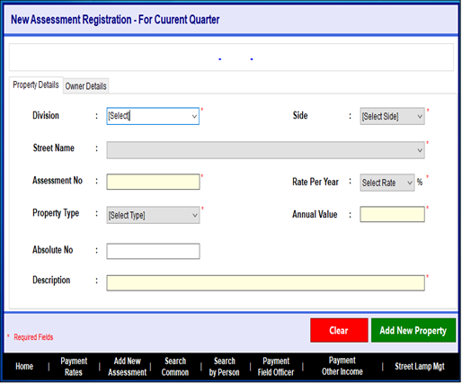

Figure - New Assessment Registration for current quarter- Property details

* This form adds new property details for current quarter new assessment registration.
* User can insert the “Annual Value”, ”Absolute No”, “Description” and select the “Division”, “Side”, “Street Name”, ”Rate Per Year”(managed by Admin) and “Property Type”.
* When the user clicks the clear button, the whole data will disappear.
* Custom Number automatically generated and used for further tasks.
* The “*”mean required data, that data should be wanted and the user not filling that data can't go to the next step.
* After adding the property details, the user can click the “Owner details” tab.
* Divisions are divided according to the subject officers.
* According to the user, system will display relevant division when the system loaded.

|  |  |  |
| --- | --- | --- |
| **Checking Officer** | **Section** | **Division Number** |
| ACO-I | AC/01 | 1/3/10/18 |
|  | AC/04 | 6/12/16/19 |
|  | AC/05 | 2/13/14/15 |
|  |  |  |
| ACO-II | AC/02 | 7/9/17/22 |
|  | AC/03 | 4/5/8/23 |
|  | AC/06 | 11/20/21/government |

### Add Owner details for the property

Figure -New Assessment Registration for current quarter- Owner details

* This from for add owner details
* The user can select the honorary title and insert the “Owner Name”, “NIC/Ref No”, “Address”, “Mobile” and “Home” and upload the picture of the owner.
* If many users owner for the one property user can enter the owner name one by one using the coma.
* Mobile number important for the send notification after the payment and inform the Arrears K form notifications.
* Before the click “Add New Property” User must fill the all details.
* User cannot enter the same customer number and cannot be duplicate Division, Street and Assessment number.
* When the user click the clear button whole data will be cleared.
* Then the user click the “Add new property”, user can add to the new property details.
* System automatically save the details of property details entered user.
* The “*” mean required data, that data should be wanted and user not filling that data he can’t go to the next step.
* When adding the new property or edit the property, system should be facilitate to select the following information form the File Number.
* ADT
* VBA
* Physical Chargers
* VL
* System should calculate the total penalty amount, date from upload the Building document (VBA) referenced from planning section.
* Approved print of after upload the “A” sheet from the relevant section, it must go through the up to ACO for submit through the relevant section.
* Also system display the “Assessment Details for A sheet” interface.
* When submit the A sheet, it numbering should be as follows.

Ex-: AC-01/2023/01

AC-01/2023/02

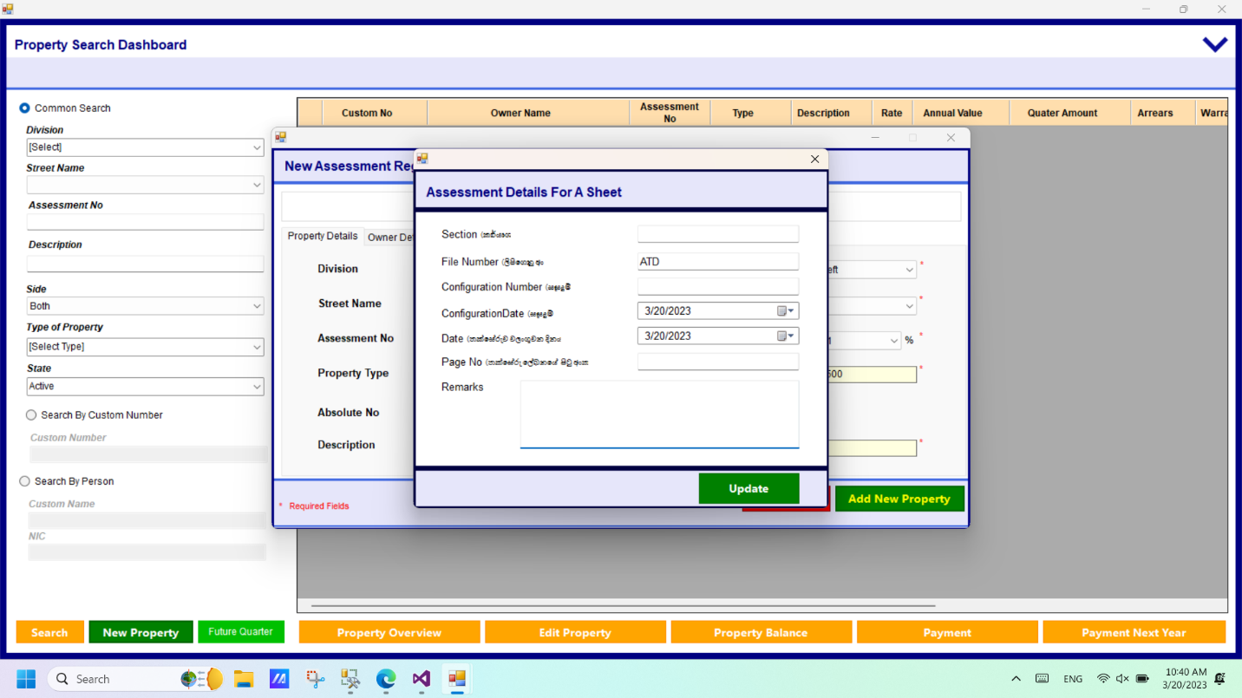

Figure - Assessment details for A sheet

* After successfully adding the property and owner details system facilitates the option to enter the Assessment details for “A sheet”.
* User has to enter the “Section” ,”Fill Number” , " Configuration Number” ,Configuration Date ,Date , Page No, remarks details.
* Then the user click the “Update “button.
* Added details are moved into the Rate approval process.

Rates

Rate Approvals

* + - User clicks the Rate approval and views the “Rate approval Manager window.”
    - There are four approvals.
* Checking officer approval
* CC Approval
* AO Approval
* Account Department Approval.
* To complete the approval process above four people must have to approve the property details.

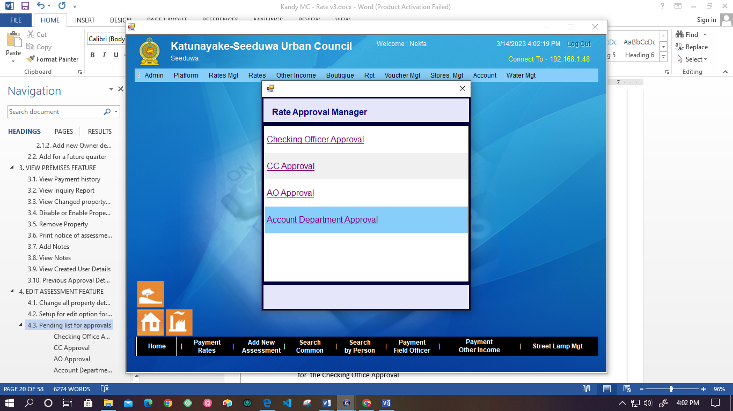

Figure -Rate approval

* According to the approval, the system adjusts the amount of debit and credit related property numbers.
* Also user can view the details of approval through the payment history.

##### **Checking Office Approval**

* When the user edits the property details, those details are moved into a pending approval for the Checking Office Approval
* Then the Checking Office can view the pending approval list.
* User can approve or reject the approval request.
* If the user clicks the approve user has to add a comment for approval.

##### **CC Approval**

* After Checking Office Approved the property details and that details are moved in to as pending approval for the CC Approval
* Then, CC can view the pending approval list.
* There is an option to approve or reject the approval request.
* If the user clicks the approve user has to add a comment for approval.

##### **AO Approval**

* After CC approves the property details, details are moved in as pending approval for the AO Approval.
* Then, AO can view the pending approval list.
* After selecting an approval request can make Approve or Reject.
* If the user clicks the approve user has to add a comment for approval.

##### **Account Department Approval.**

* After AO approves the property details, details are moved in as pending approval for the Account Department Approval**.**
* Then the Account Department can view the pending approval list.
* After selecting an approval request can make Approve or Reject.
* If the user clicks the approve user has to add a comment for approval.
* After the Account Department approves the edited property details, the approval process is completed.
* According to the requirements of the council, “A sheet” will be generated as follows.
* And also the system will automatically generate the Amount to be paid forward from configuration date.

Figure - Property Assessment details report

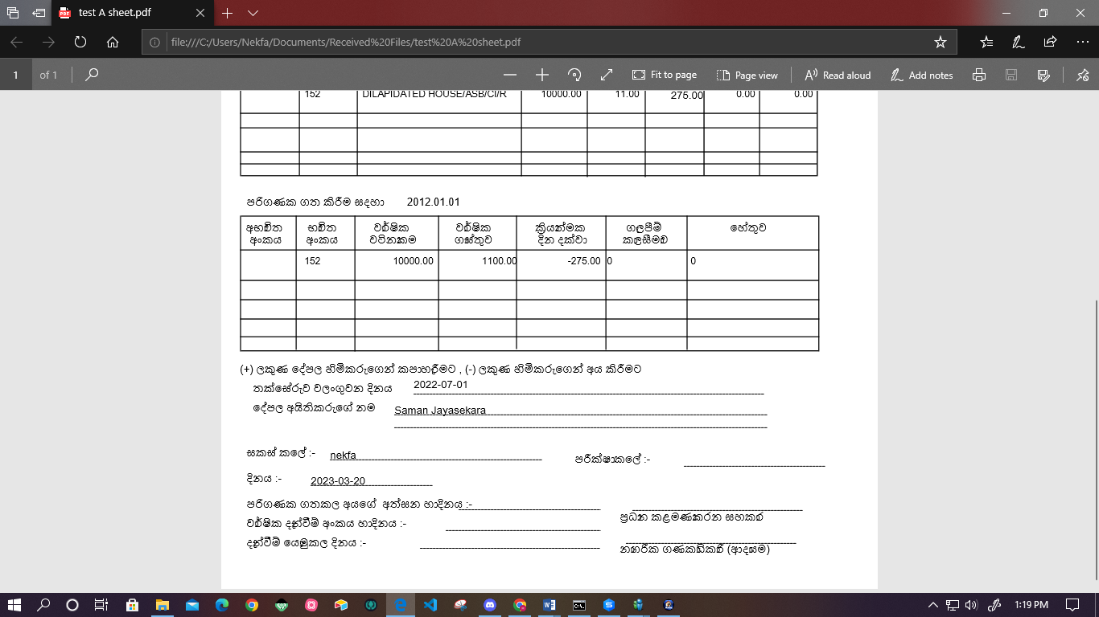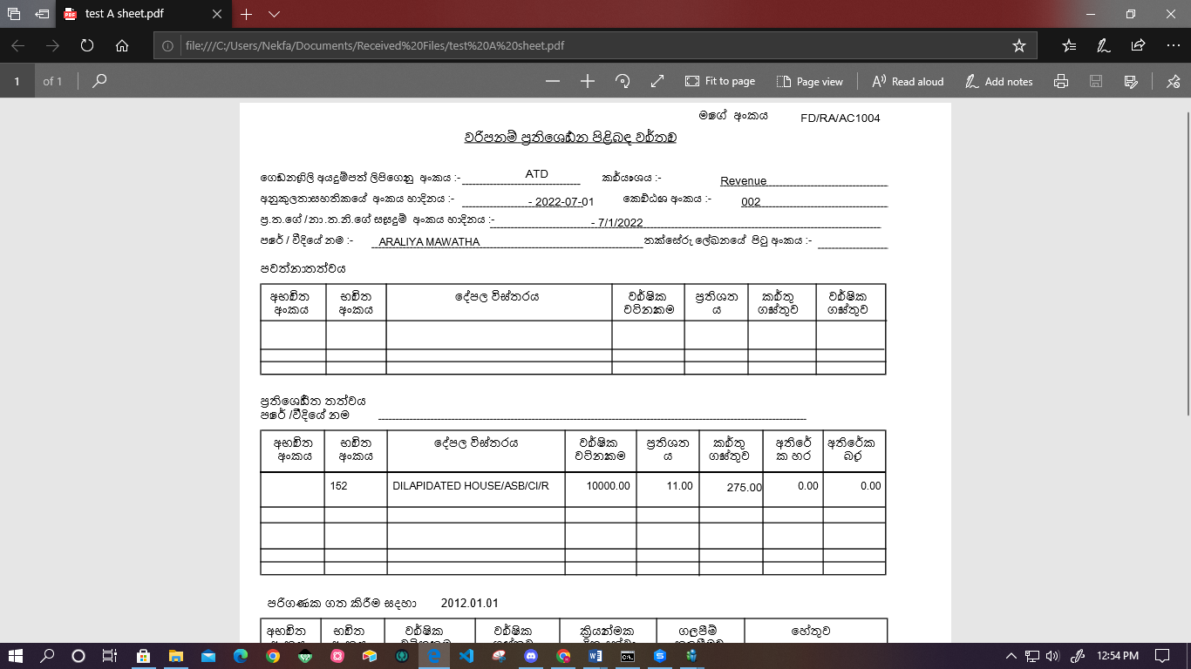

## **Add new property for a future quarter**

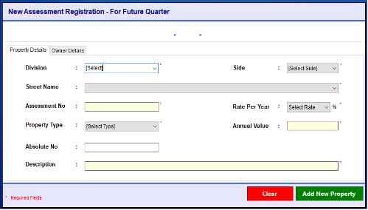

Figure - New Assessment Registration for future quarter

* This form adds new property details for future quarter new assessment registration.
* User can insert the “Annual Value”, ”Absolute No”, “Description” and select the “Division”, “Side”, “Street Name”, ”Rate Per Year” and “Proper Type”.
* If many users own the same property, users can enter the owner name one by one using the comma.
* Mobile number important for the send notification after the payment and inform the Arrears K form notifications.
* Before the click “Add New Property” User must fill in all the details.
* User cannot enter the same customer number and cannot duplicate Division, and Street number.
* When the user clicks the clear button, the whole data will disappear.
* Then the user clicks the “Add new property”, user can add to the new property details.
* System automatically saves the details of property details entered by the user.
* The “*”mean required data, that data should be wanted and the user not filling that data he can’t go to the next step.
* System facilitates adding the property details for the future quarter and no billing will be done.
* Add for future quarter function features are the same as the current quarter.
* But not calculate the quarter amount.

# **PROPERTY SEARCH**

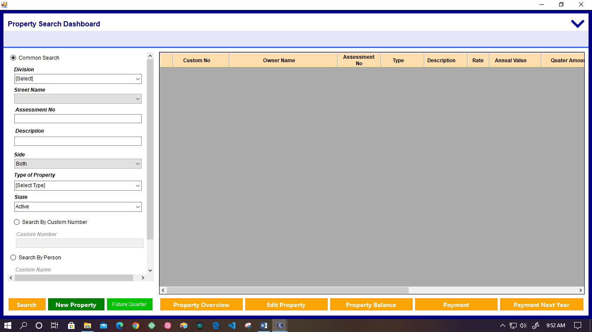

Figure - Property search

* This form for property search
* There are three ways to the property searching
* **common search**
  + - The user selects the “Division”, “Street Name”, “Side”, “Type of Property” and “State”
    - User can insert the “Assessment No” and “description” on the form and click the “Search button” and the user can find the information for each person.
    - If user don’t need to fill everything, only “Division” and “Street Name” are enough for the finding system

##### **By Division, street, property no**

* User can search the property details list using division (a dropdown box within the option of division number), street name, and property Number.

##### **By Description**

* System facilitates the user to get the result of property details searching by the Description.
* When the user doesn’t know the full description, can write between the percentage marks and the knowing description (ex: - %Perera%).

##### **By Property Type**

* System facilitates the user to get the result of property details searching by the Property Type.
* Property Types are included in the drop-down menu.
  + - **search by customer number**
  + The “Customer Number” is the only inserting option in this field
  + After the insert the customer number user can search the details by clicking the “Search” button.
    - **search by person**
* The user enters the “Customer Name” and “NIC”.
* When the user doesn’t know the full name he can write between the percentage marks and the knowing name (ex: - %Perera%).

# **VIEW PREMISES FEATURE**

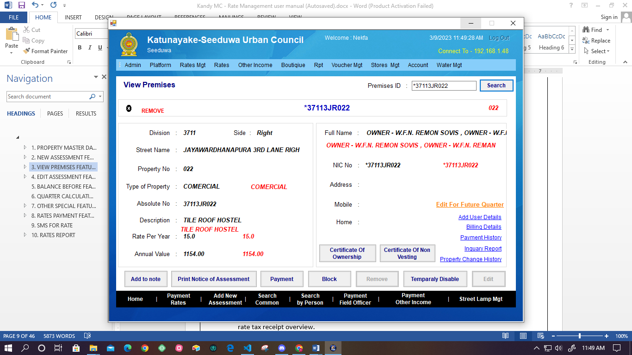

Figure -New Assessment Registration for current quarter- Owner details

* In this section user can view the property and owner details of the particular owner already existing.
* User can view premises details by searching the “Premises ID”.
* System provides the following facilities with this section.
* View payment history
* Inquiry Report
* View property change history
* Edit for future Quarter
* Add user details
* View billing details
* Print certificate of ownership
* Print certificate of Non vesting
* Add to note
* Print notice of Assessment
* Blok Property
* Remove property
* Temporary disable property

### **View Payment history**

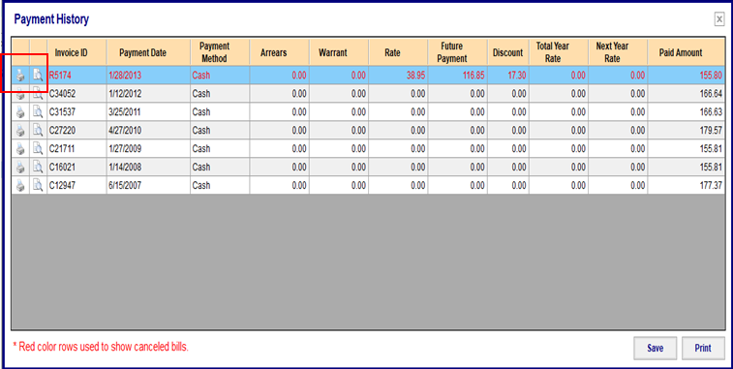

Re print bill

Figure -View property history

* + Using this frame, the user can view the payment history.
  + Following details displays in the each payment history list .(Invoice Id, Payment ,Date Payment Method, Arrears ,Warrant ,Rate ,Future Payment ,Discount ,Total year rate ,Next year rate ,Paid Amount)
  + User can view the “Daily receipt Tax Overview” using the view icon.
  + Using the “Print” button and print icon, users can print the list of payment history reports.
  + Red colored rows used to show canceled bills.
  + When the print the details, do not change the details and print the same bill number.
  + User can export the document using the “Save” button.

## **View Inquiry Report**

Figure -View property inquiry report

* + User can view the property inquiry report using this interface.
  + If the balance is changed, this interface displays the details.
  + User can get a list of details by selecting the particular date (System shows the calendar – From date -, To Date) duration from searching.
  + User can save inquiry reports.
  + Using the print button and print icon, users can print the list of inquiry reports.
  + Following details displays in the inquiry report details list.(Date ,Description ,Arrears Balance ,Warrant Balance ,Rate Balance ,Future Balance ,Total)

## **View property change history**

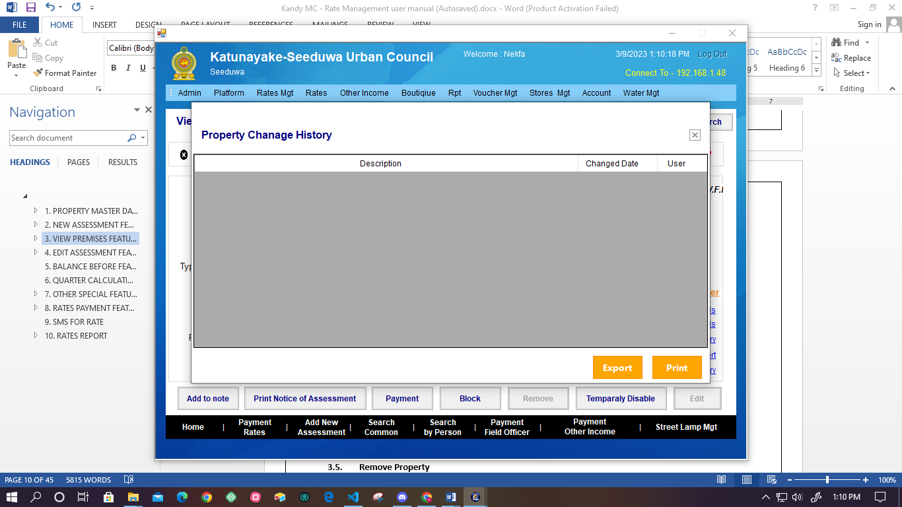

Figure - Change property history

* + This interface for viewing properties changes details from the start date of the system.
  + User can view Description, Changed Date, and User Name.
  + User can export the report of property change details.
  + User can export the list of changed property details report.

## **Disable or Enable Property.**

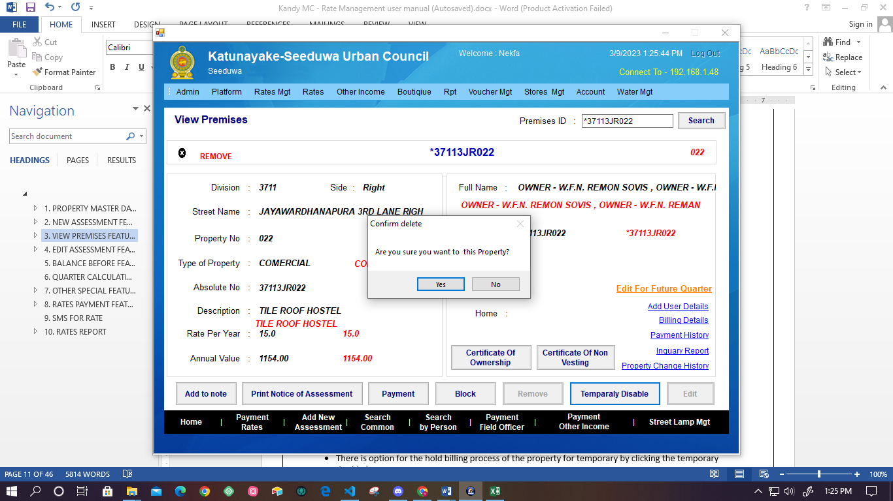

Figure -Confirm disable

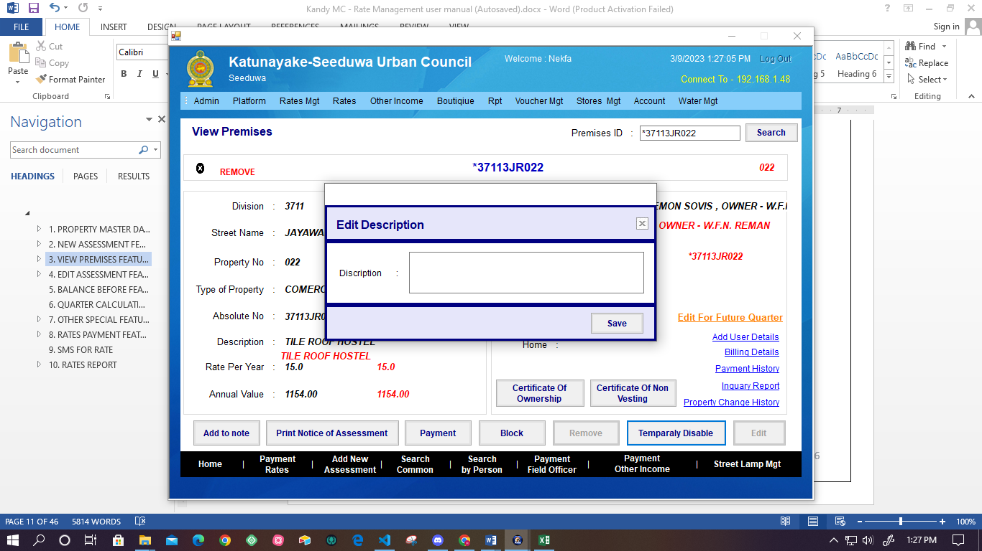

Figure - Edit Description

* There is an option for the temporary hold billing process of the property by clicking the temporary disable button.
  + Manage the allowed users by using the user permission.
  + In this case not use the property number, but keep the details by system.
* When disabling the property, stop the billing according to the quarter and stop the penalty calculation.
* But can pay and print the “K form”.
* If has the arrears are related to the property, that details can print using the arrears report.
* User can add descriptions for the disabled.
* After saving the disable, the user can view the details in property change history.
  + Also there is an option for enable the disabled property (Same as the enable process).
  + Inactivated property, Whether or not to warrant up to the occasion of active, there should be an option for the select permanent or temporary.
  + Also there should be an option for add or not missed property quarter amount.
  + If missed property warrant amount add, system should automatically calculate that all missed amount.

## **Remove Property**

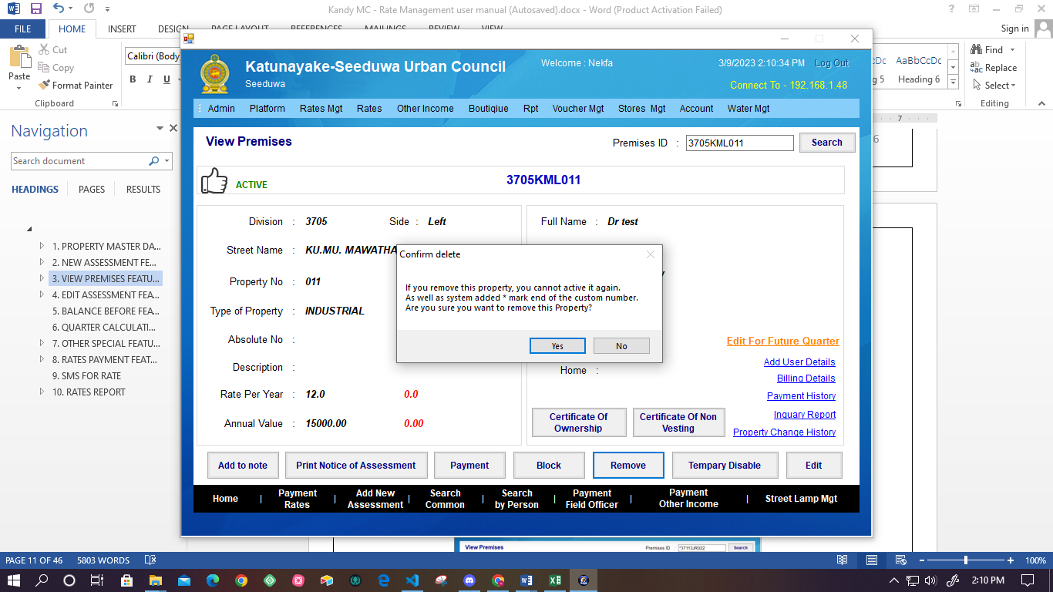

Figure - Remove property



Figure -Remove description

* User can remove the property details using “Remove” button, and then, before the remove execution, system display the confirmation box.
* After remove the property, not calculate the quarter calculation and not process the bill.
* “K form” is not generate.
* If there is Arrears related property, those details can print using the Arrears report.
* User cannot activate removed property.
* Removed property number can use another property.
* Removed property completely remove from the system.
* System facilitate manage to user permission for the remove. But can view details of the property.
* If removed property in the mistaken, system should facilitate to option for the state of the being.

## **Print notice of assessment (KFORM)**

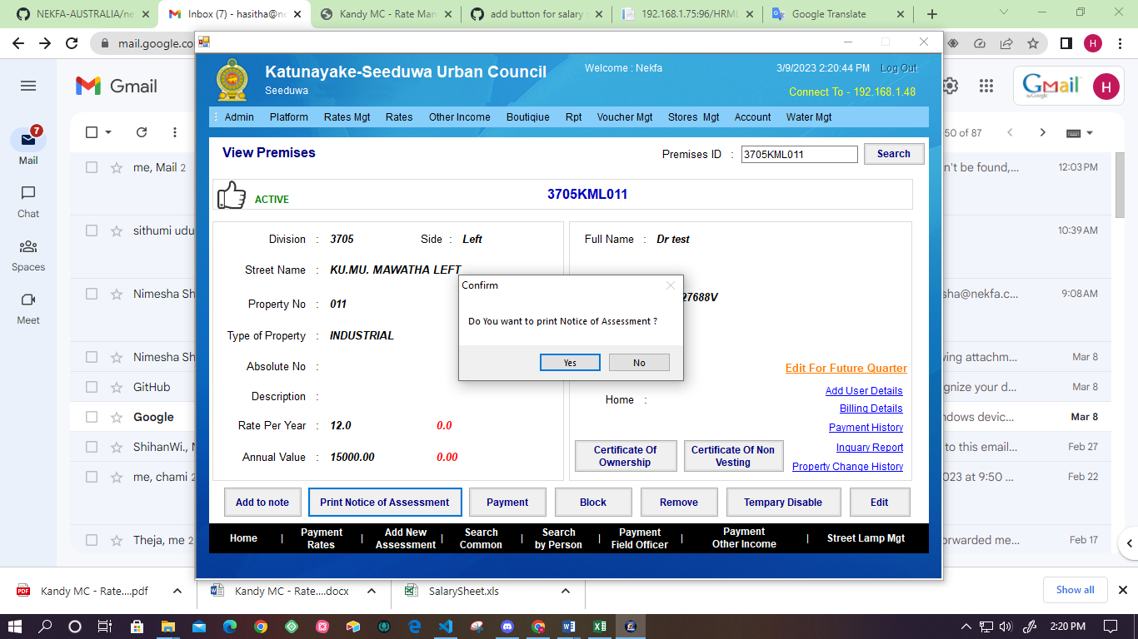

Figure - Print notice Assessment Confirmation

* User can print the Notice of Assessment according to the related year.
* Using the property change history option, the user can reprint the Note of Assessment.

## **Add Notes**

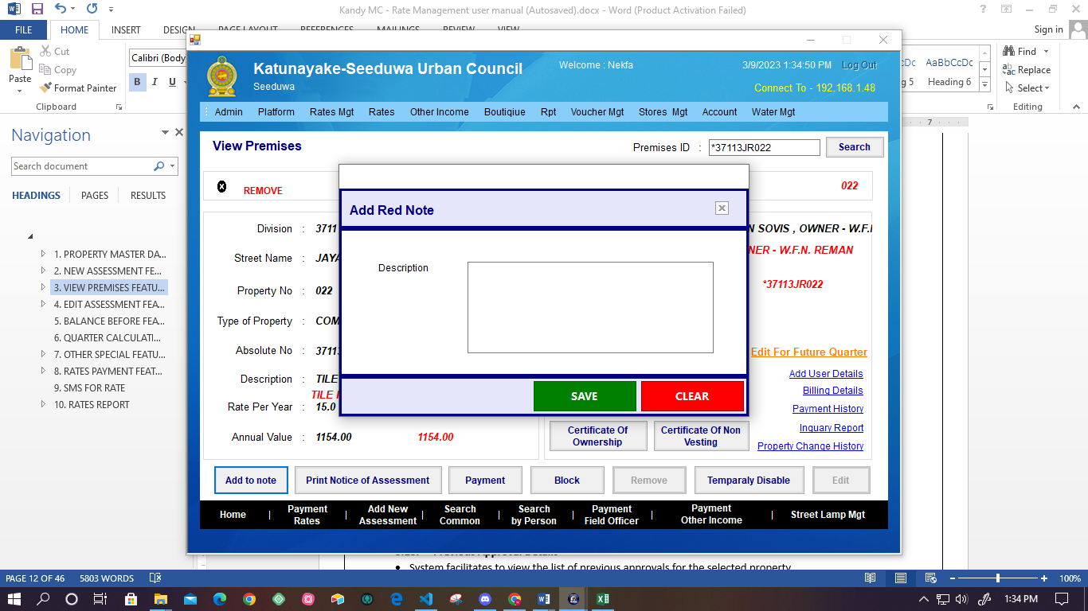

Figure -Add red note

* Users can add a note for a selected property using the “Add to note” option.
* After clicking the options system displays the Box to add to the red note.
* Users can describe red notes and have options of saving and clearing the note.
* Display the red not in the Property overview, Edit property, and property for the payment interfaces.

## **View Notes**

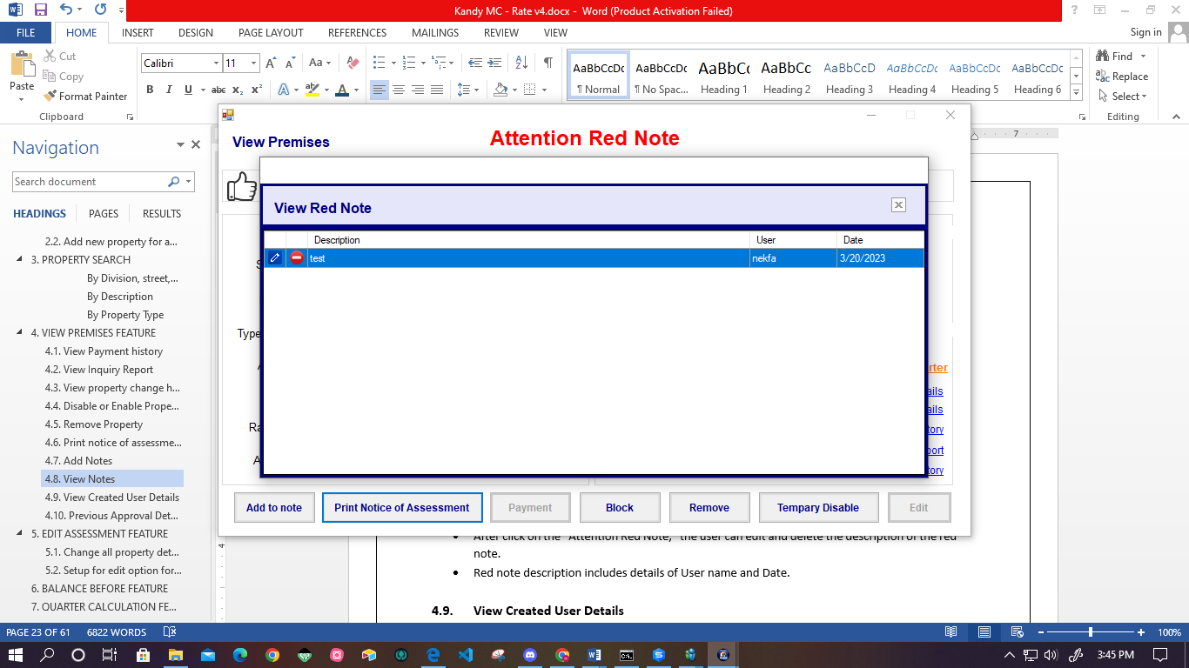

Figure - View red note

* User can view the red note from the Property Overview, Edit property and property for payment interfaces.
* After clicking on the” Attention Red Note,” the user can edit and delete the description of the red note.
* Red note description includes details of User name and Date.

## **View Created User Details**

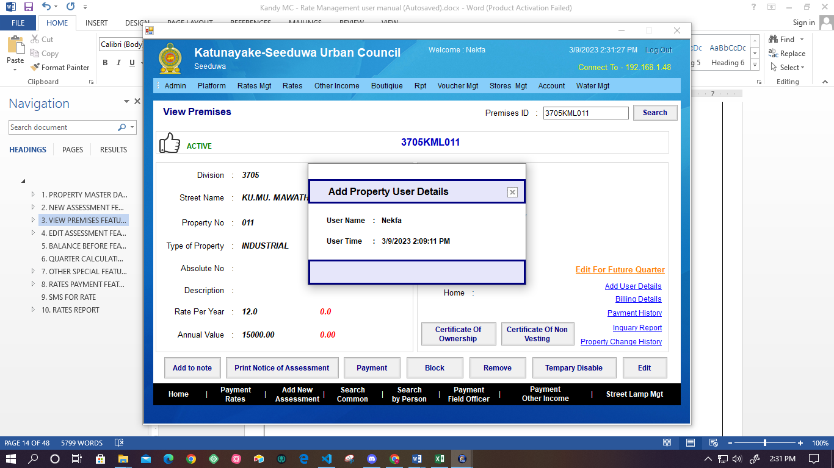

Figure - View created user details

* + - * User can view the details of the created user details.
      * System displays add user details as User name and User Time.

## **Previous Approval Details**

* System facilitates to view the list of previous approvals for the selected property.
* System facilitates the get soft copy and hard copy.

## **Block**

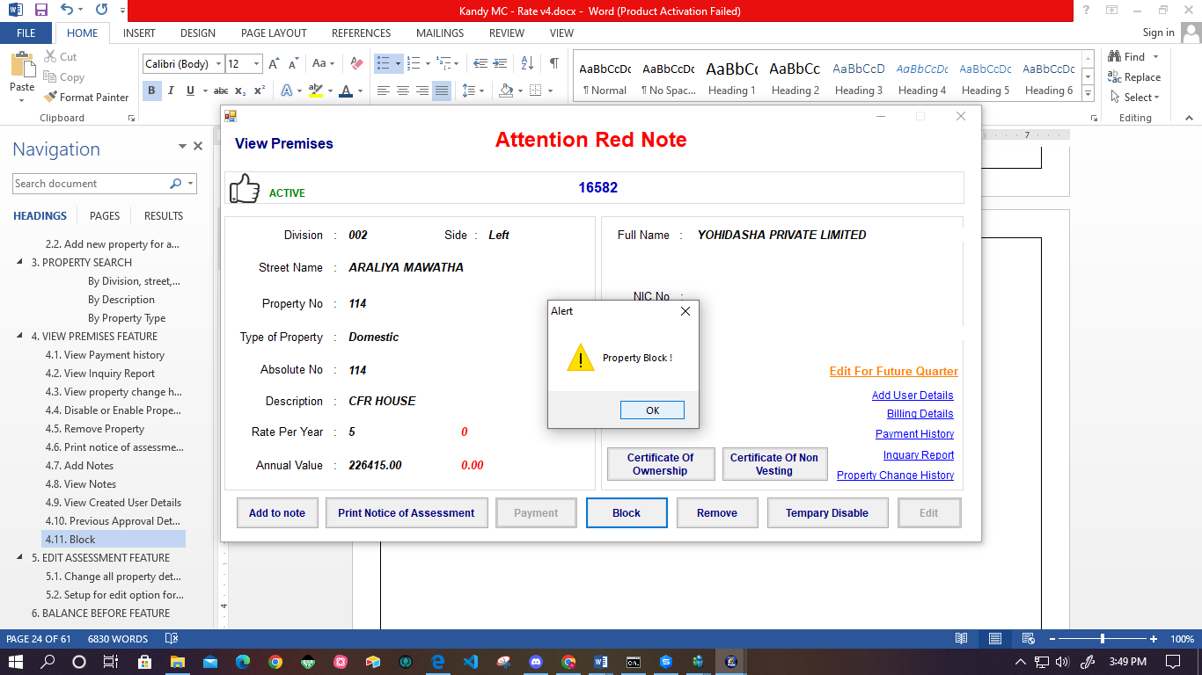

Figure - Block property

* After blocking the property, the user cannot Edit, Payment, Remove and Disable the property.
* Cannot do payment and not calculate quarter update.
* Also there is an option for unblocking the property.

# **EDIT ASSESSMENT FEATURE**

## **Change all property details**

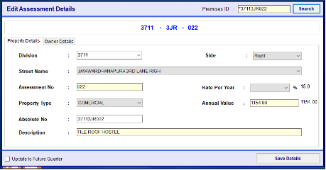

Figure -Edit assessment details

* User can change the property details already added, using this interface.
* User cannot add the duplicate property number.
* If many users own the one property, users can enter the owner name one by one using the comma.
* Mobile number important for the send notification after the payment and inform the Arrears K form notifications.
* Before the click “Add New Property” User must fill in all the details.
* User cannot enter the same customer number and cannot duplicate Division, and Street number.
* Divisions are divided according to the subject officers.
* According to the user, system will display relevant division when the system loaded.
* User can view the changed property details through property changes history.
* System automatically gathers the information for “A sheet” and generates that sheet.
* User can get the soft copy or hard copy from the system.
* User can save the edited details.
* User can edit the property details through the common search “Edit Property” button.

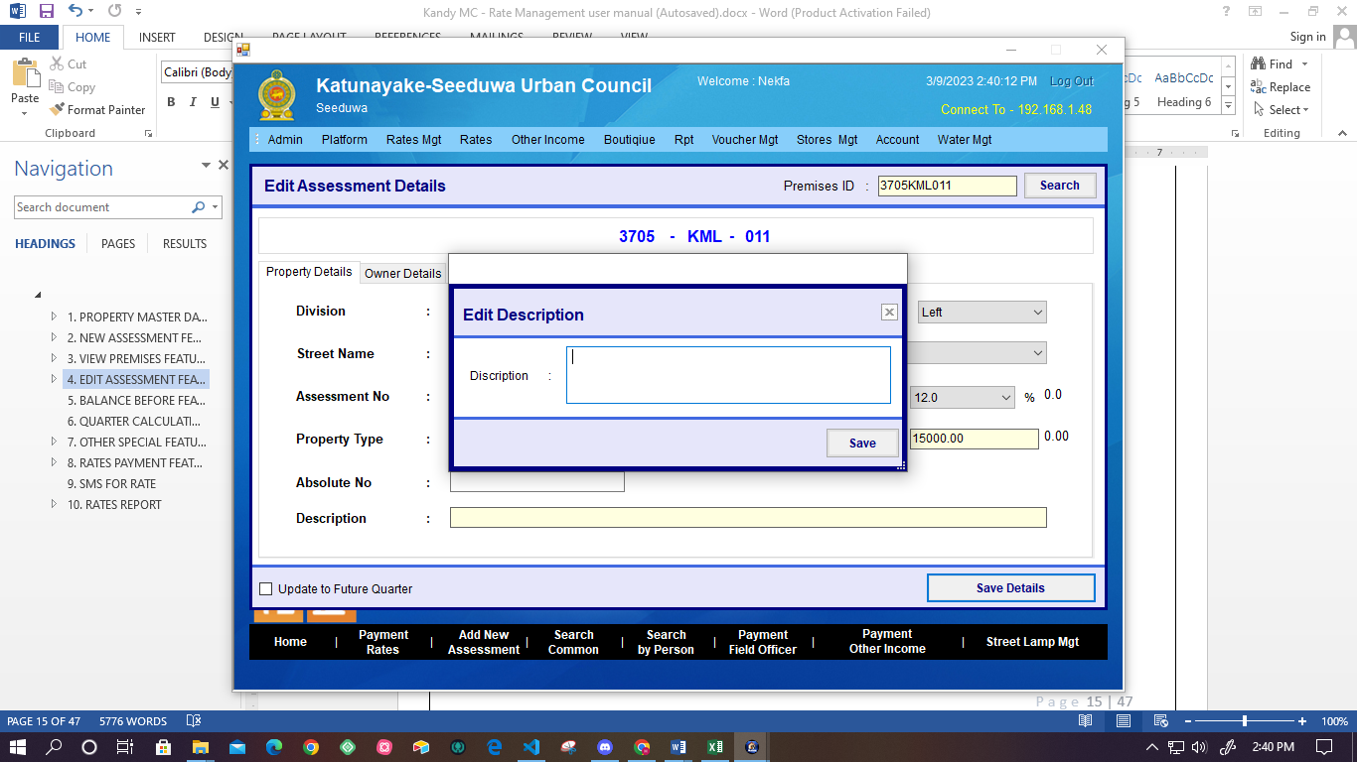

Figure - Add edit Assessment description

* User can add the description about the edit details using this interface.
* Property changed details are updated only after the approved.

## **Setup for edit option for the approval status**

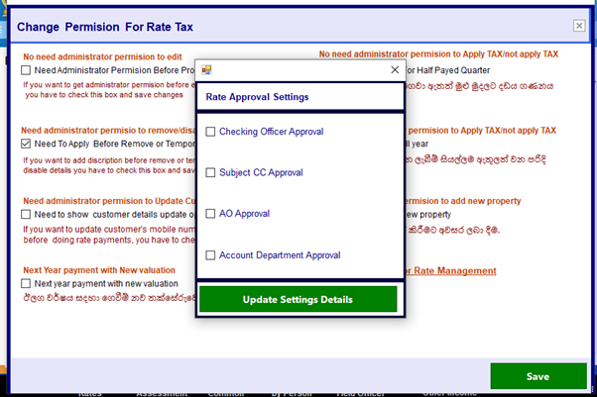

Figure -Setup for edit option for the approval

## **Property of Non resident**

* System should facilitate the option, select to the property is resident or Nonresident.
* There should be Category icon for the Non – resident property.(Option for the Remark for amount of the cut off each quarter and regarding the warrant.)
* System should facilitate to get the report of property of Non-resident with following details.
* Owner Name and Custom ID
* Property Number
* Street
* Property value for Annual
* Description of property
* Amount of cutoff and warrant
* Remark for approval

# **QUARTER CALCULATION FEATURE**

Figure -Quarter Update Process

* This form for the quarter calculation feature.
* The quarter calculation is done only once for the entire system.
* Quarter calculations allow for January 1, April 1, July 1, and October 1.
* If not done, quarter calculation for the related quarter system does not allow the billing process.
* Billing, Arrears, and Assessment should calculate according to the each quarter.
* User should be able to change the, date of data updated according to quarter as January 1, April 1, July 1, and October 1.

**Process of the quarter calculation**

* only calculated active properties
* System checks whether the last quarter balance remains for the related property.
* If the balance remains, the penalty fee is calculated according to property type for full quarter.
* **Penalty fee = (Quarterly Amount* penalty)/100**
* If the corresponding quarter is active, calculate the quarter amount and add it to the current year.
* Else quarter is Inactive or Remove quarter amount is 0.
* On January 1, the amount to be paid in the last year of the process will be collected as arrears.
* If a discount has been received for the relevant property numbers, it will be reduced as payment.
* User cannot reverse after that process and all other account reports of the quarter, updated when quarter calculation.
* When clicking the “Update” button, the user can update the calculated quarter.

# **RATES PAYMENT FEATURE**

Figure - Rates Payments

* User can view the payment window by using the Common search option.
* User can view the **basic details, balance details and regarding the amount paid** for the related property.
* Following details are displayed as basic details.
* Custom Number
* Full Name
* Division
* Street name
* Property Number
* Address
* NIC No
* Annual value
* Annual Rate- System automatically calculate (**Annual value *Year rate/100)**
* Quarter Rate – **(Annual rate /4)**
* Following details are displayed as the balance details.
* Arrears Payable – Until previous year 12/31
* Warrant Costs – Total warrant billing of the current year.
* Year Rate – Total quarter amount for the current year (only Display the billing quarter amount for the current date.

EX: - If we are in 2 nd quarter total rate show as tow quarter

* Total Due amount – Total summation of Arrears Payable, Warrant Costs, Year Rate
* Overpayment – Amount paid for future quarter or future year
* Received Discount – Discount received of current quarter
* Calculate Discount Amount as follows
* Up to Quarter 1 - Amount for first quarter, if on January 31 or before the January 31, 5%
* Up to Quarter 2- Amount for the second quarter, if on April 30 or before the April 30, 5%
* Up to Quarter 3- Amount for the third quarter, if on July 31 or before the July 31 , 5%
* Up to quarter 4 – Amount for the entire year, if between January 1 – 31 and if paid Total amount 10% discount.
* User can view the last payment information.
* There is an option for viewing payment history details.
* As well as the system calculates the discount amount automatically considering the current rate.
* System facilitates following payment types for the payment.
  + - Payment by cash
    - Payment by cheque
    - Payment by credit card
    - Do
    - Payment by online
* User has to enter the payment amount to the system.
* After saving, payment is successful, the system generates the invoice and sends SMS to the customer.
* Using the payment history user can view the details of payment by cash, Cheque, or card.
* Online payment should be auto updated and send notifications through SMS.

## **Auto discount calculation.**

## **Ability to pay any amount**

* In the rate payment section, the user can search customer details by searching Customer ID.
* The system displays the customer details and Balance details.
* Also, the system facilitates paying payment amounts by cash, cheque, or credit card.

## **Payment between Branches**

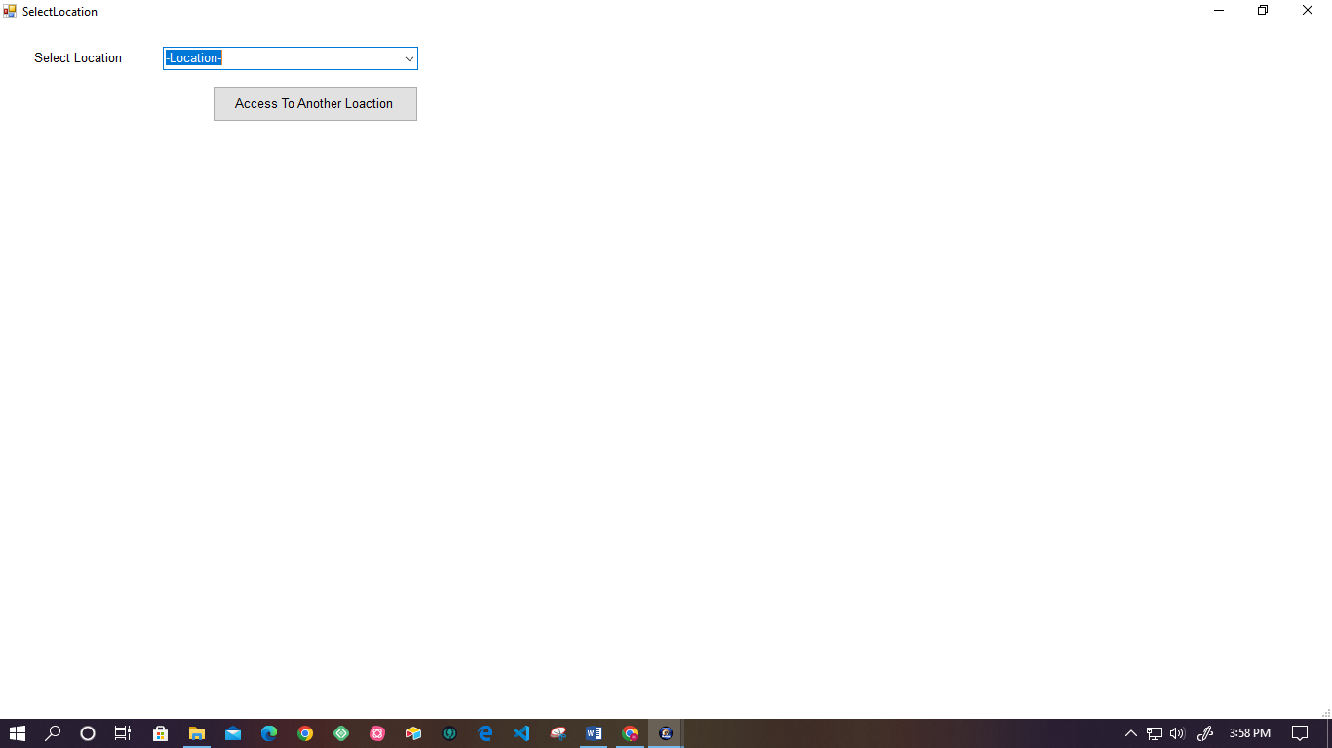

Figure -Payement between Branches

* System facilitates to user to payment between two branches.

Location – Drop-down menu

* System update report daily in related branches.

## **Check Online Receive Payment**

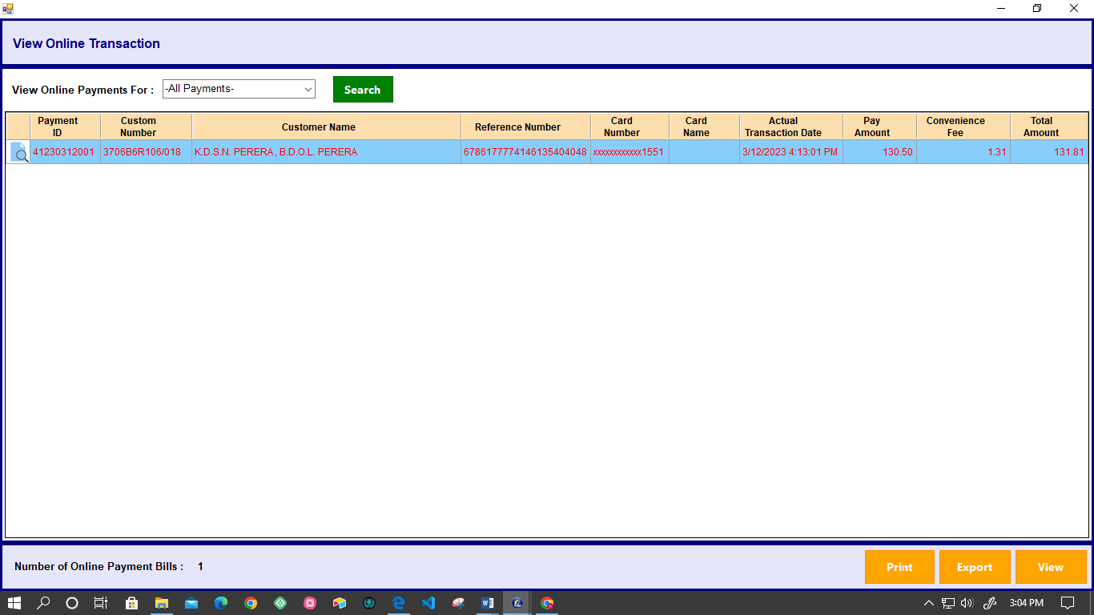

Figure 30- View online receive payment

* System facilitates the user to check the details of online payment.
* System displays the not reconciling online received payment.
* Using the search icon, the user can view the overview.
* Also there is an Accept and Reject option for the payment.
* Need automatically reconcile process for online payment

## **Multiple Property Payment**

* User searches for the property details of the customer.
* System displays the multiple payments overview.
* User selects the Payment Type.
* User clicks the ‘Go to multiple payments “.
* Following details are displayed in the multiple payment list view.
* Premises ID
* Payable Amount for end of quarter 4
* Discount for end of quarter 4
* Pay amount
* System displays the following details.
* Total due amount
* Total Pay amount
* Users can select the payment method using the drop-down menu.
* Then system displays the following details
* Receipt Number
* Amount
* System facilitates displaying all receipts.

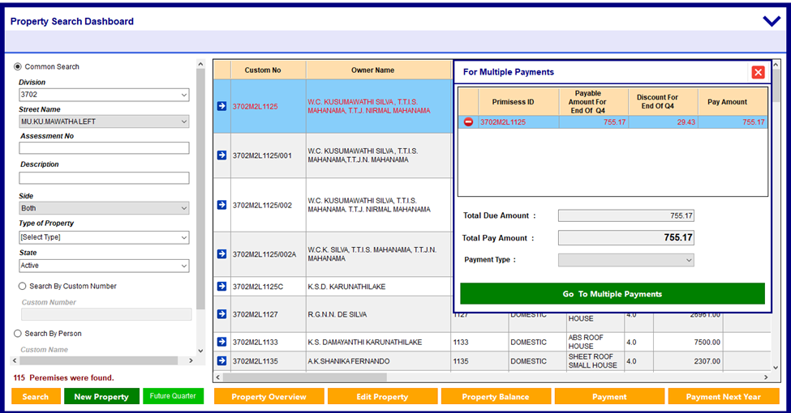

Figure - Multiple property payment

## **Payment for Upcoming year tax**

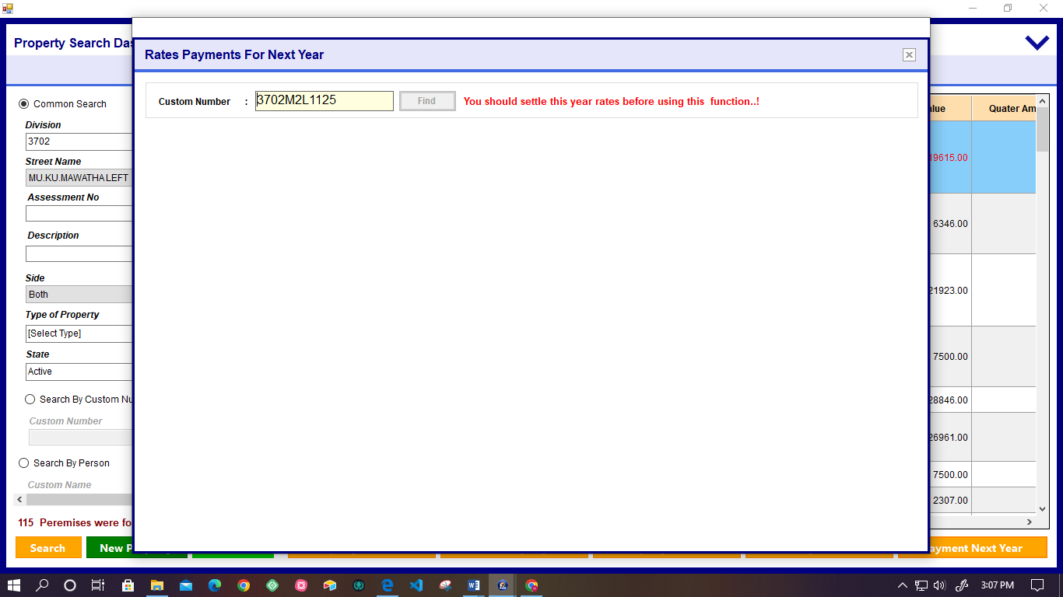

Figure - Rates payment for next year

* System facilitates users to pay for the upcoming years.
* User must pay for the current year, if they do next year's payment.
* System displays the following details
* Customer Details
* Balance Details
* Discount
* Amount for each quarter.
* User can view the payment history and Past Balance.
* User has to select the Payment Type, Description, and Payment amount for the payment.

## **Re-copy function**

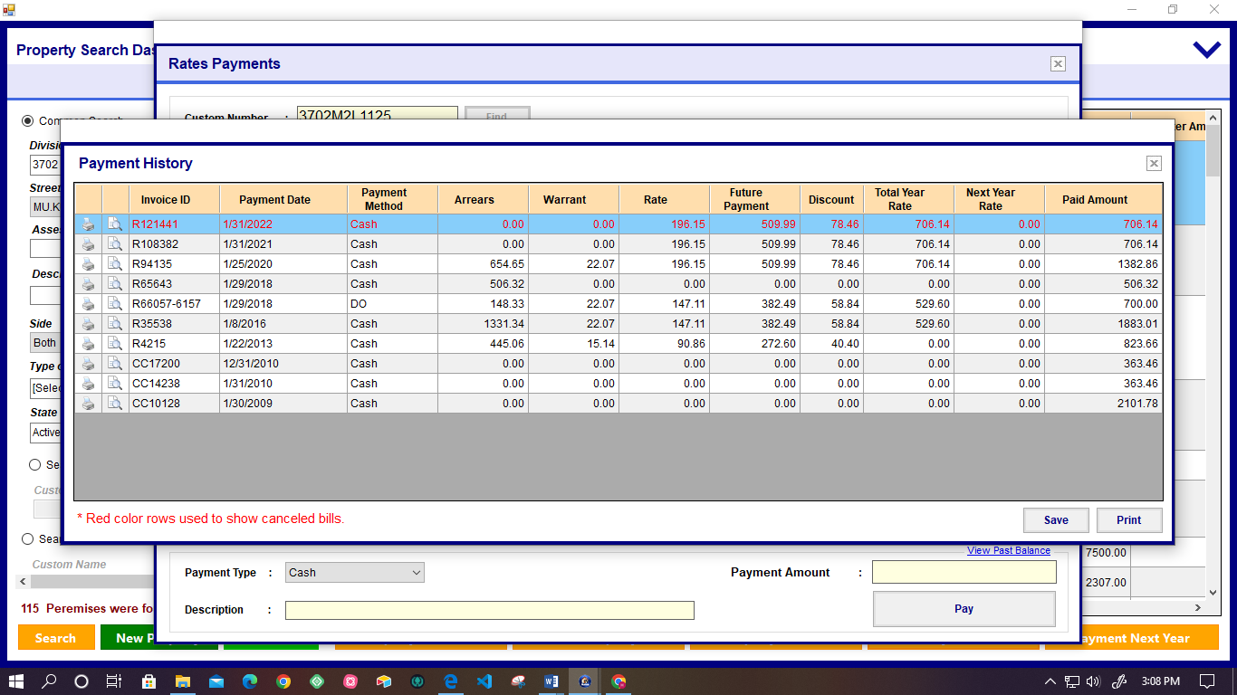

Figure 33- Re copy function

* If the user cannot do the bill for some reason, the user can print again that bill without changing the details using the print icon.

# **OTHER SPECIAL FEATURE**

## **Mange fields officers**

Figure -Add field Officer Details

* This form for manage fields officers.
* Then the user enter to the “Officer ID”, “Full Name”, “Address”, “Contact Number” and the select the honorary title with the “Full Name”.
* When the user click the “Add New” that data will be save.

## **Bill issue for the Field officers**

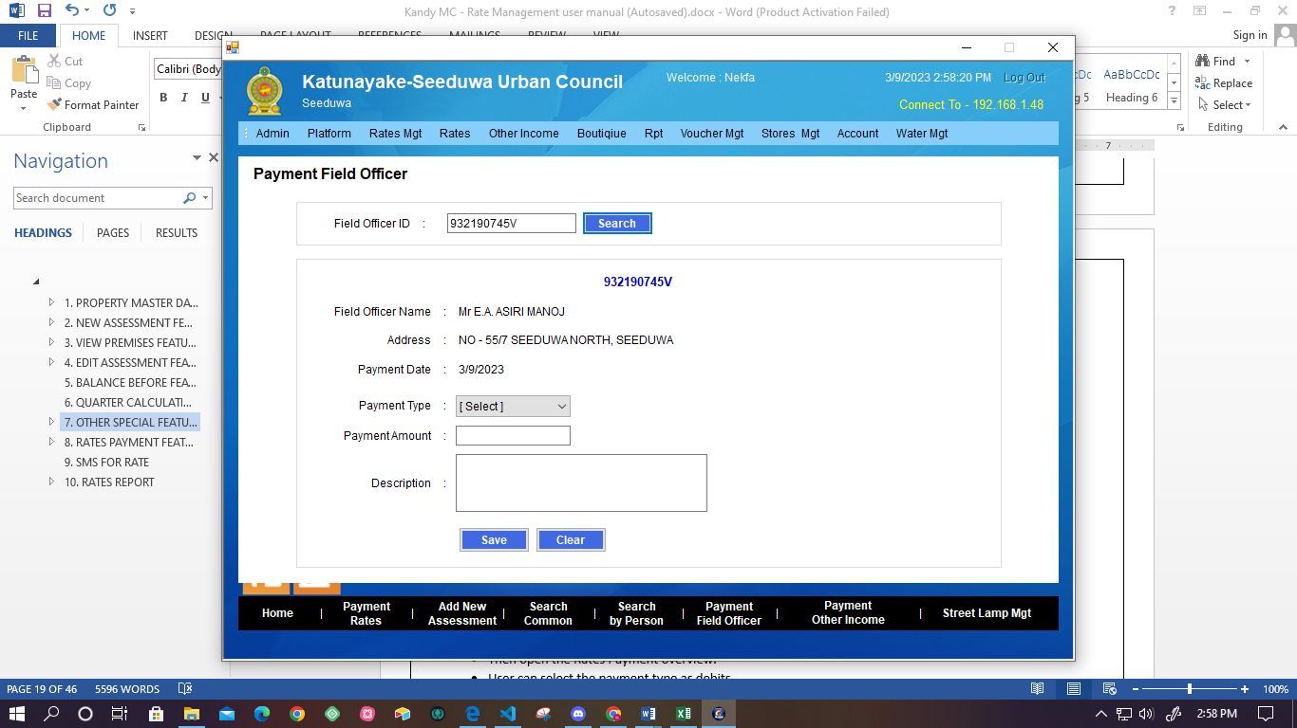

Figure - Payment Field Officer

* System facilitates the user to issue a bill for the field officer using this interface.
* User searches field office details by searching the field Officer ID.
* Then the system displays the Field officer details, and the user has to select the Payment Type, Payment amount, and Description of the payment.
* User can save and clear the details.

## **Update Credits for property**

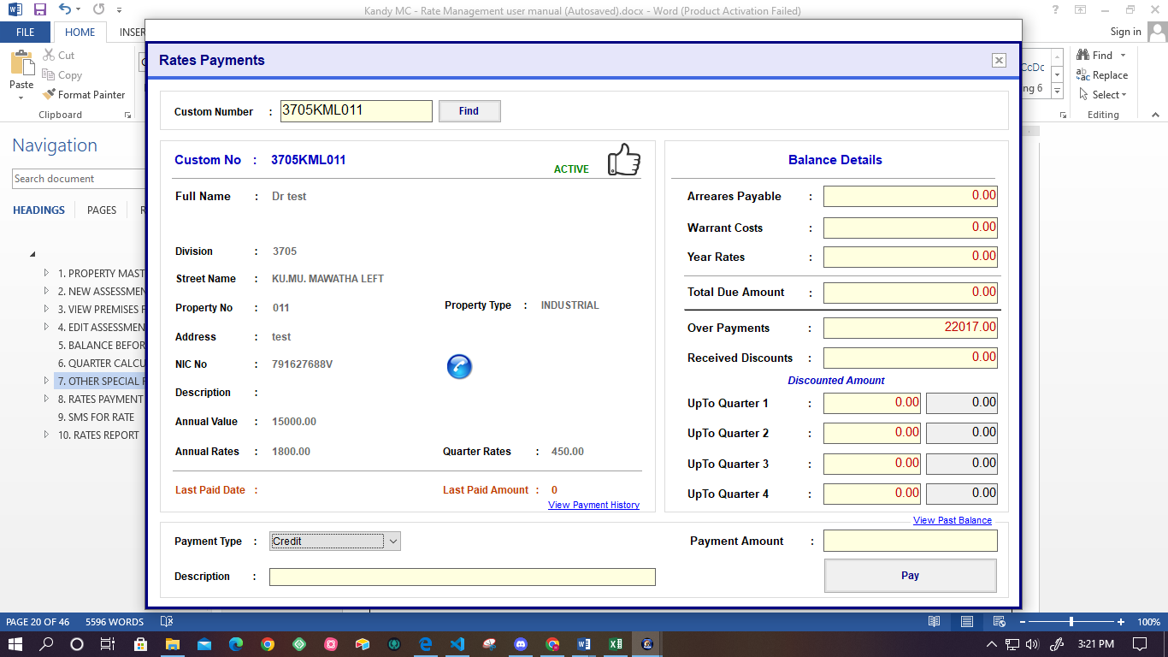

Figure - Update credit for property

* User can update payment type as Credit using this interface.
* User clicks the payment.
* Then open the Rates Payment overview.
* User can select the payment type as credits.
* Also can add the Description and Payment amount.
* Then click the “Pay button.”

## **Update Debit for property**

Figure - Update debit for property

* User can update payment type as debit using this interface.
* User clicks the payment.
* Then open the Rates Payment overview.
* User can select the payment type as debits.
* Also can add the Description and Payment amount.
* Then clicks the “Pay” button.

## **Cancel receipt**

Figure -Daily Receipt Summery

* This form for daily receipt summary for canceled receipt.
  + User can get the cancel receipt summary report.
  + User can search the cancel recipe by selecting the Location, Date Duration, Account Year, user, Receipt Order (Ascending, Descending), and category.
  + User can Save, Print, and view the Cancel Receipt report.
  + System should facilitate to the change time of the expiration period for the issued recipe but not make the daily payment.

## **Add Manual Warrant for Properties**

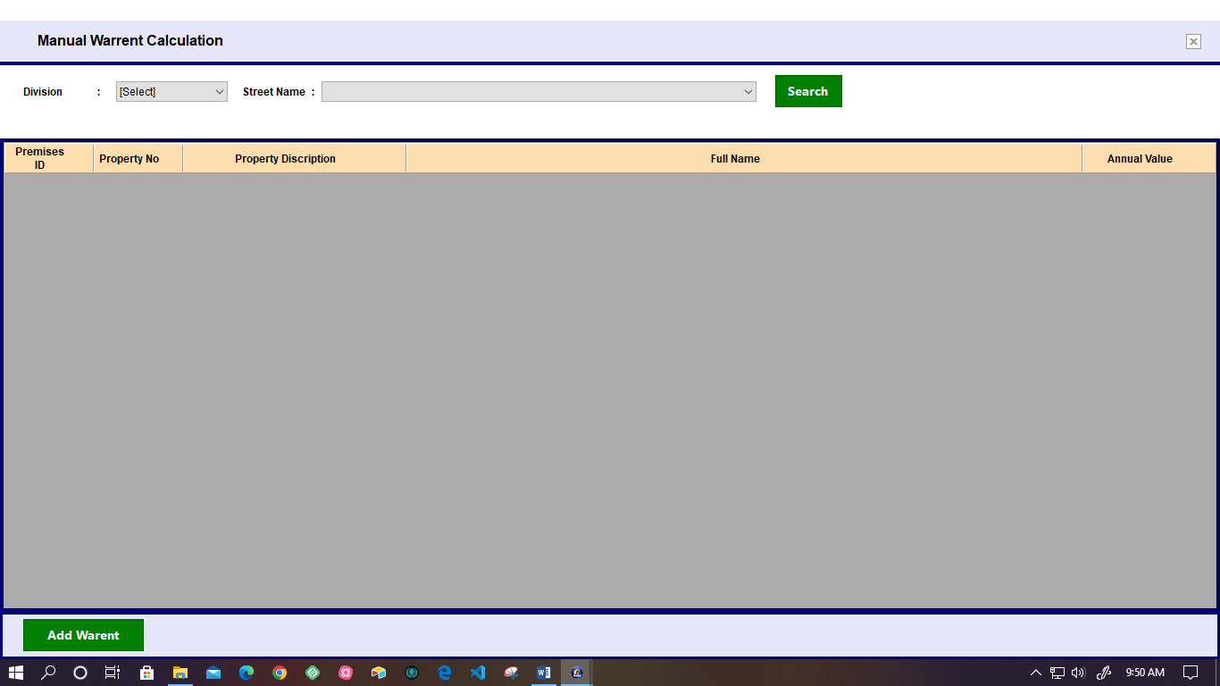

Figure -Add manual warrant for property

* This form for add manual warrant for properties
* The user insert the “Division” and “Street Name
* After click on a “Search button” user can find the property information by using the chart.
* Then the system displays the list of property details (Premises ID, Property No, Property description, Full Name, Annual value.
* When the user clicks the “Add Warrant” he can add the warrant for the form.

## **Manage Bill Printer Settings**

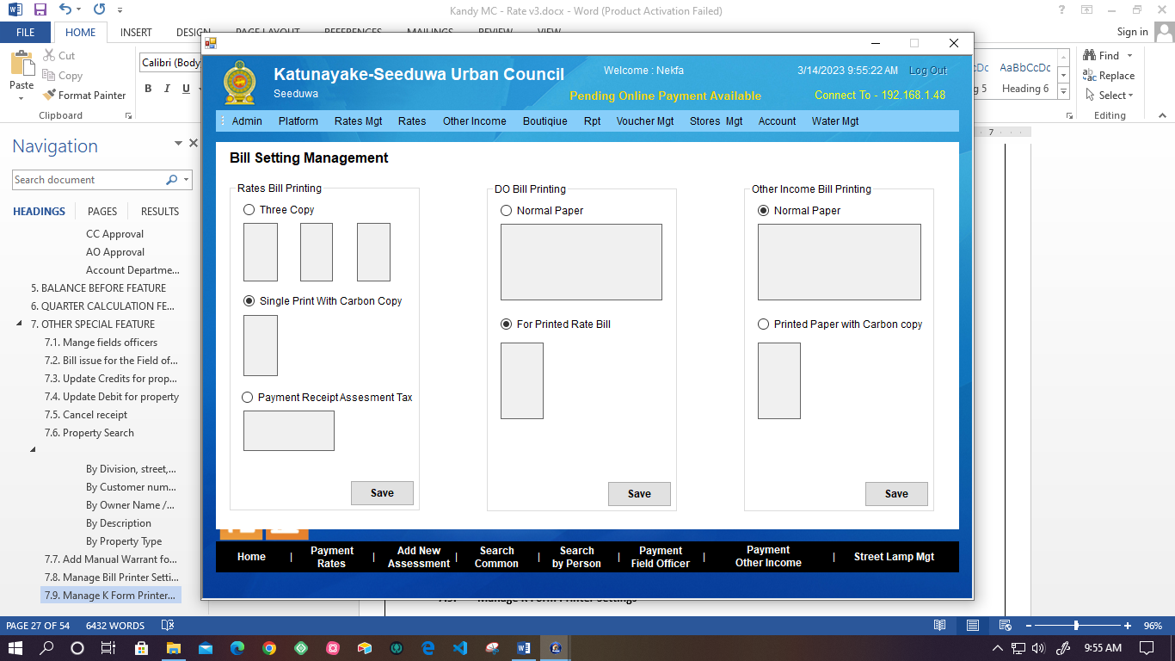

Figure - Bill setting Management

* System allows the user to manage the bill printer settings. There are options to print bills.
  + - * + Rates bill printing
        + Do Bill printing
        + Other income bill printing
        + After setting the bill printing option, the user has to save settings using the “Save” button.

## **Manage K Form Printer Settings**

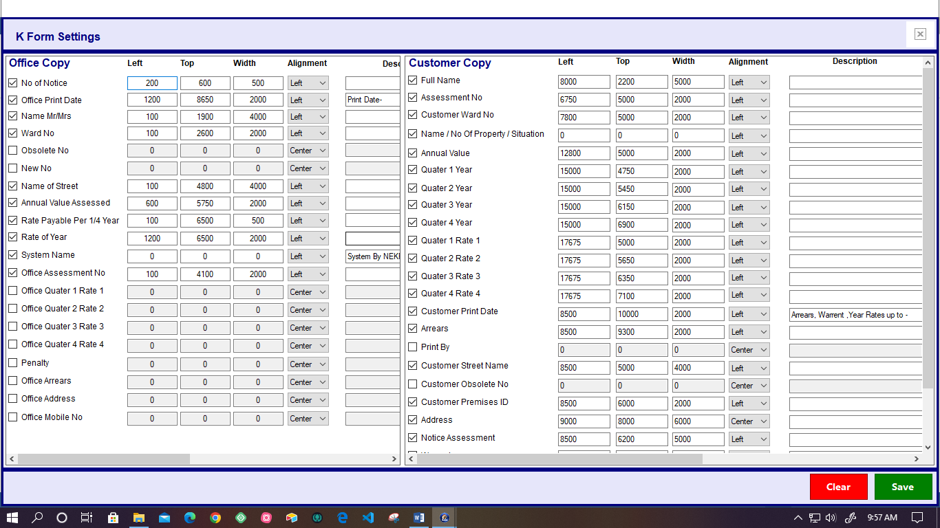

Figure - K form settings

* This form for the K-Form printing setting.
* The system facilitates managing Office copy and Customer copy of K form printer settings.
* The user has to mark the available details.
* User can save or clear the updated settings details.

## **Manage Red Notice Printer Settings**

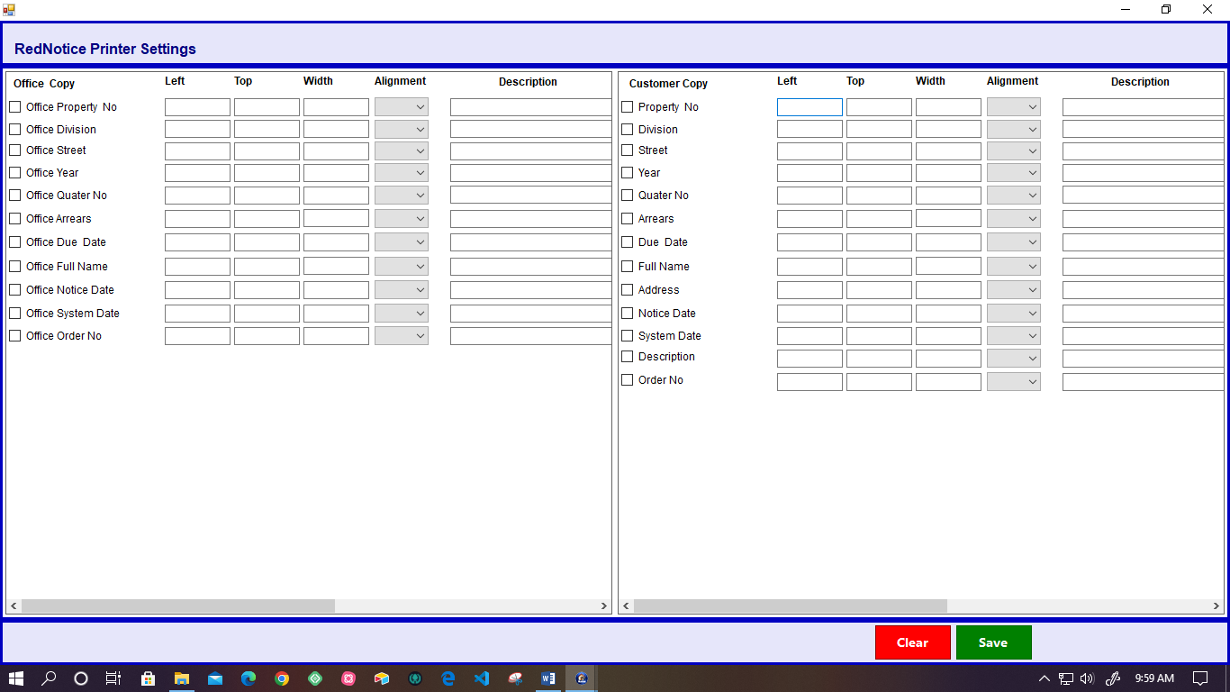

Figure 42- Red notice printer settings

* User can manage the Red notice printer settings; in this functionality, the user has to mark each related detail as available.
* Also, user has to set each property. (Left, Top, Width, Alignment (Dropdown box), and Description).
* Then, the user can save or clear the setting data using the “Clear” and “Save” buttons.

## **Rate validation**

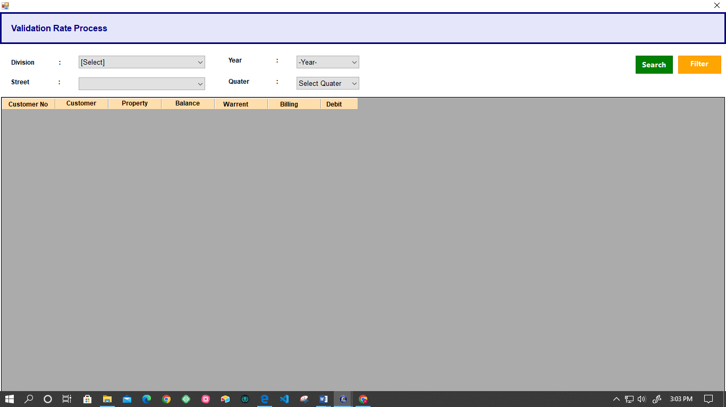

Figure - validation Rate process

* User can get the rate validation details by using the following details.
* Division – Drop -down
* Street- Drop -down
* Year- Drop -down
* Quarter- Drop -down
* Following details are displayed in the details of the Rate validation process.
* Customer Number
* Customer
* Property
* Balance
* Warranties

# **SMS FOR RATE**

* System sends Discount details to the Owner
* System sends Arrears details to the Owner
* System sends SMS API based.
* User can view sent SMS using SMS portal.

# **RATES REPORT**

## **Daily Receipts**

### **View Daily Paid Receipts**

Figure -Daily Receipt Summery

* This form for view daily paid receipt
* When the user selects the “Receipt date”, “User Name” and “Receipt Oder”
* After doing this step the user can click the “search report” button and the user can get the data according to this.
* Also, users can search, view, print, and export reports.

### **View Daily Cancel Receipts**

Figure -Daily cancel Receipt summery

* User can select the receipt date and search the details of the canceled receipt on the particular date.
* There is a facility to get receipt details in ascending or descending order.
* User can print the cancel report, export the cancel report, and view the cancel report.

### **View Daily Receipt Summary Report**

Figure - daily Receipt summery report

* In this section, the user can get a summary of all types of payment summary details on a particular date.
* System facilitates print, search, export, and view the summary report.

### **View Rate Tax Daily Credit Report**

Figure - Rate Tax current Report

* This interface for the view Rate Tax Daily Credit report.
* User has to select the payment type (Multiple select) using the drop-down menu, date duration, and division.
* Then, the user has to select the type of category.
* System fetches the search result and displays it as a list.
* User can search, view, export, and print the daily credit summary report according to the particular time. Also, the system has facilitated changes in the payment type.
* System facilitates to search, view, and print, export, save the Rate Tax Daily credit report.

## **Credit Summary Report**

Figure -credit Summery report

* User can view all credit summary report details.
* User can get the details by searching the following options.
* Time duration
* Change Property Type
* Receipt issue category
* The Following section is included in the Credit summary report.
* **Credit Details**

Following details are include in the credit details report

* Date
* Arrears Payment
* Warrant Payment
* Rate payment
* Overpayment
* Bank Fee
* Discount
* Paid Amount
* Credit
* **Summary details report**

Following details are included in the summary details report.

* Total Arrears
* Total warrant
* Total Yearly Rate
* Future Payment
* Total Bank fee
* Total Discount
* Total Credit
* Total Debit System facilitates the user to Export, Print, and View the Credit details and Summary details report.

## **Get Credit Summary Report Division wise**

Figure -Get credit summery division wise

* User can get the credit summary report Division wise.
* Also, users can search the details in a particular time period and division.
* There is an option for export, print, and view the search summary report.

## **View Current Arrears Report**

Figure - View current Arrears report

* System has given the option to search using division, street, side, owner name, and property type.
* User can get details less than, more than, or between wise arrears details.
* Also, users can Save, Print, and view the report.

## **Current Arrears Summary Report**

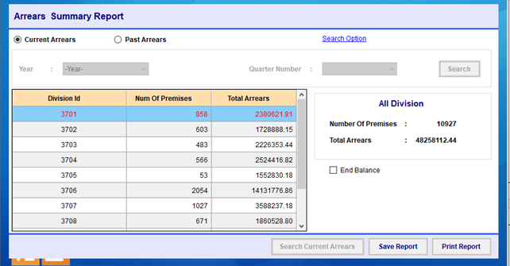

Figure -Current arrears summery report

* + - * User can search current arrears summary report by selecting the year and quarter number.
    - System has given the option to Save and print the summary report.

## **Past Arrears Report Management**

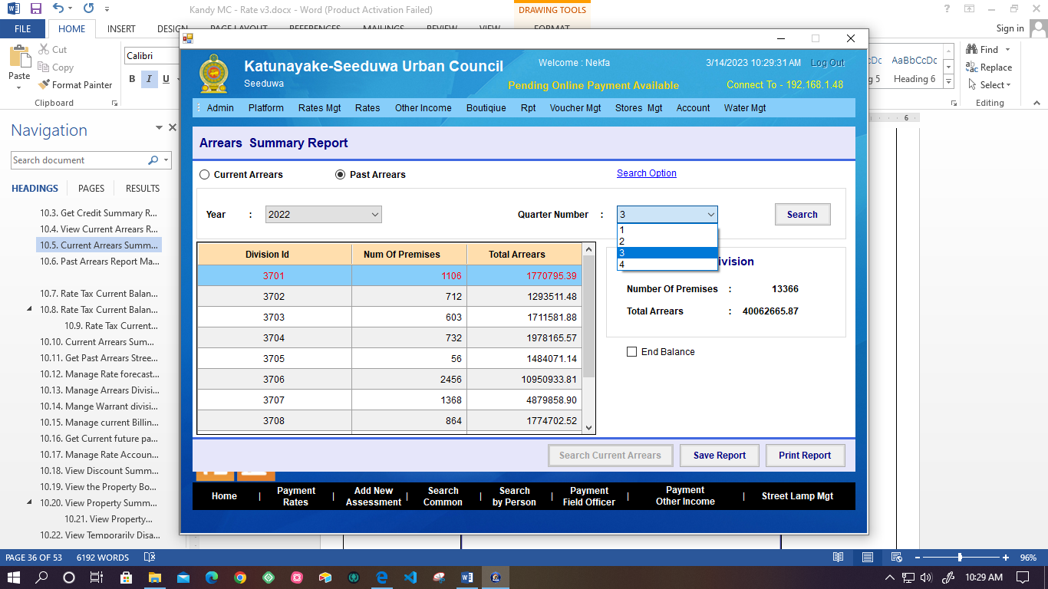

Figure - Past arrears report

* + User can search past arrears report by selecting the year and quarter number.
  + User can save and print the report.

## **Rate Tax Current Balance Report Management**

Figure -Rate tax Quarter Balance report

* + User can get the Rate Tax Current Balance Report by searching the division, Street Name, and Side.
  + Also, the system has facilitated the printing, saving, and viewing of the report using each icon.

## **Rate Tax Current Balance Division Summary Report**

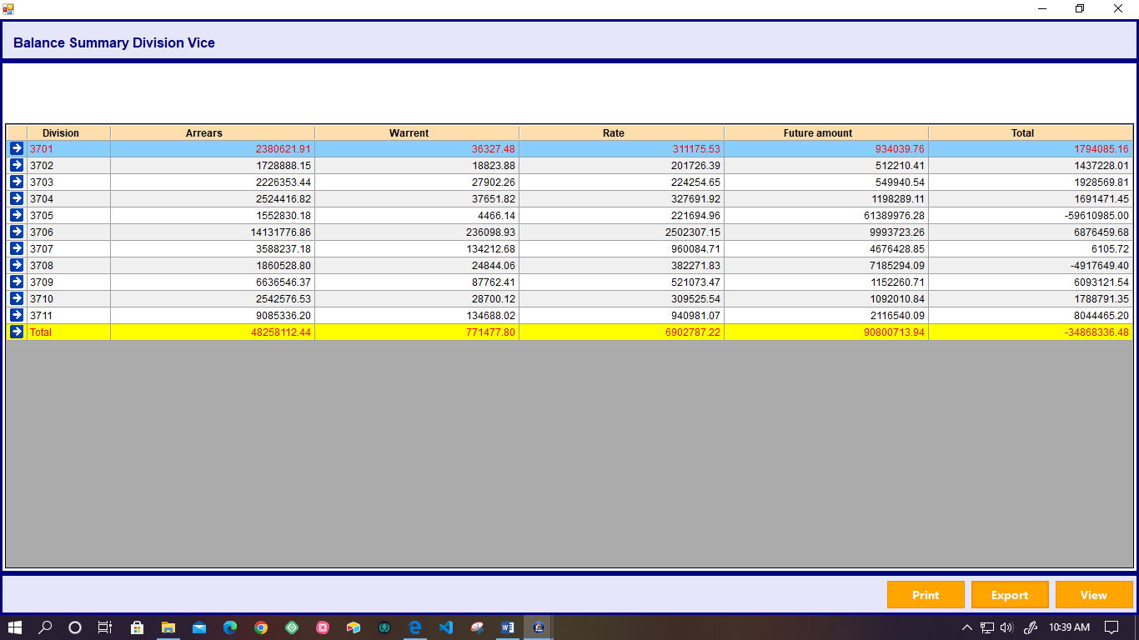

Figure - Rate tax current balance division-wise

* + System facilitates giving a current balance summary report division-wise.
  + System displays the total Arrears, Warrant, Rate, Future amount, and Total.
  + User can Print, Export, and View the balance summary.

## R**ate Tax Current Balance Summary Report**

Figure - Rate tax current Balance summary report

* User can search the details of Rate Tax current Balance summary report by searching the Division, Street name, and Side.
* Then, the system displays the list of details for each Customer.
* Also system facilitates the print, save, and View the Current balance Summary.

## **Current Arrears Summary Report (Streetwise) Management**

Figure 41 -Current Balance Summary (Streetwise)

* + User can search the current balance streetwise using Division ID.
  + User can print, export, and view the streetwise current balance report using Print, Export, and View icons.

## **Get Past Arrears Street-wise Summary Report**

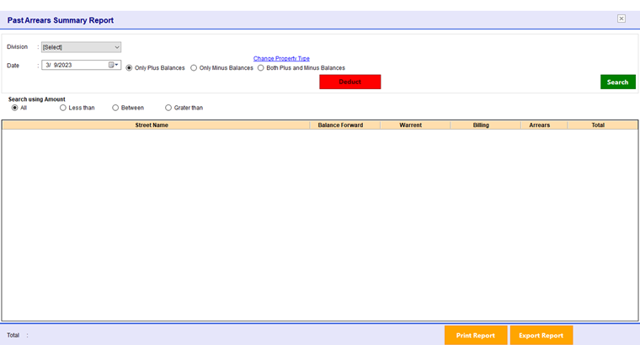

Figure 56- Past Arrears summary report

* Following options have to select by the customer.
* Only plus Balance
* Only Minus Balance
* Both plus and Minus Balance.
* User can search amount all, less than, greater than, or between.
* User can change the property type.
* System facilitates user to Search, Export, and Print the past Arrears summary report by search division and Date.

## **Manage Rate forecast report**

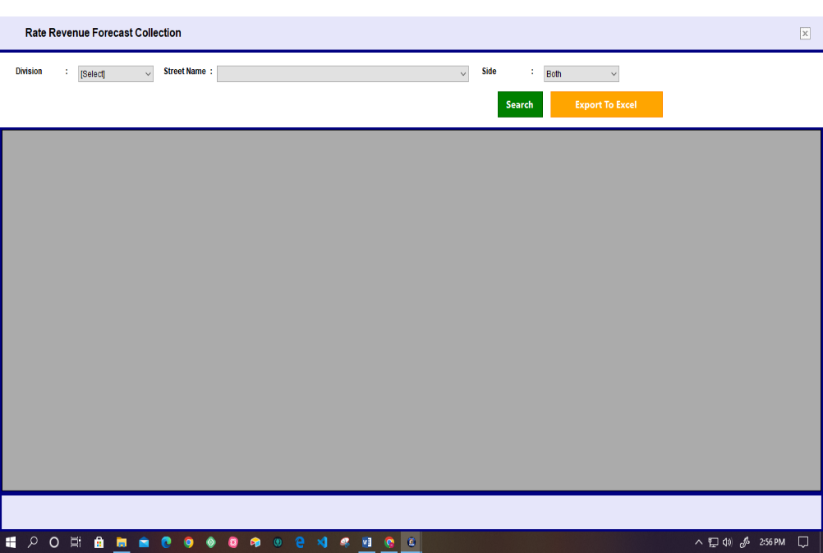

Figure - Rate forecast Report

* User can search the forecast rate using the Division, Street Name, and side.
* Also, after the search system fetched and displayed the result.
* User can export the report to the excel sheet.

## **Manage Arrears Division-wise Summary Report**

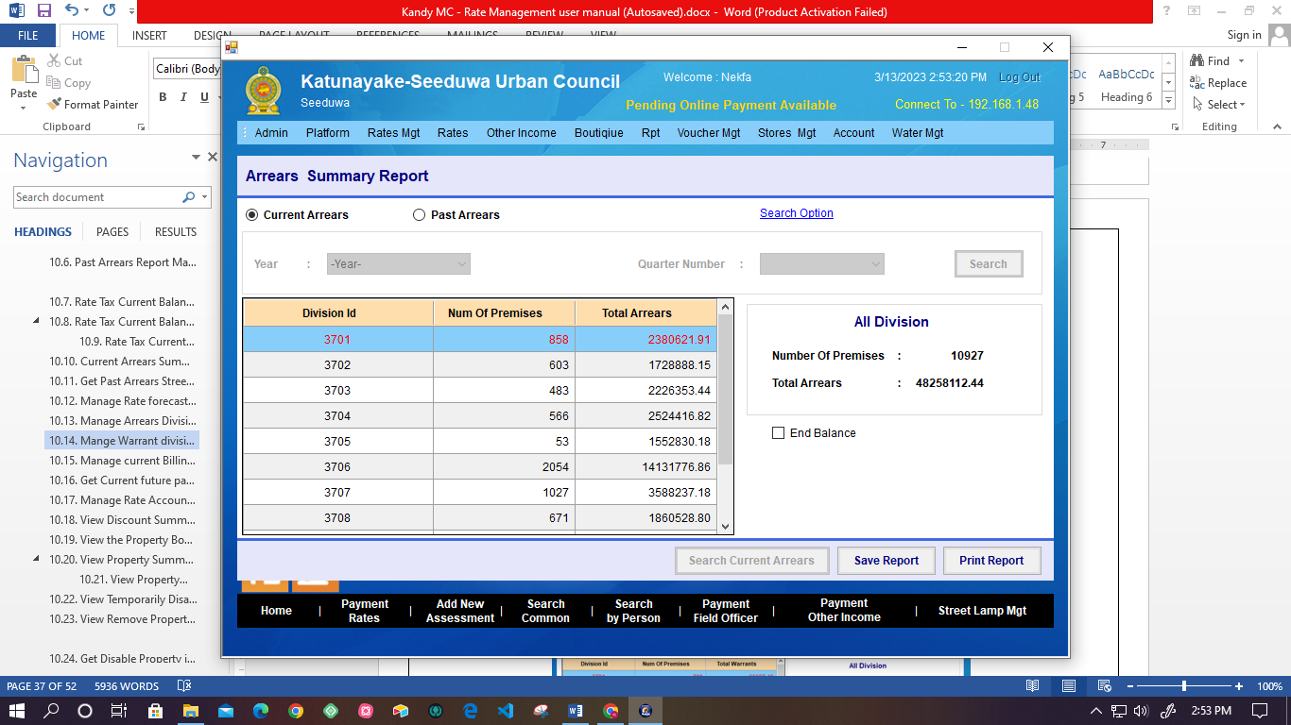

Figure -Arrears Summary report- Division wise

* System displays the Total arrears according to each Division ID.
* User can Save and print the report using the Save and Print icons.

## **Mange Warrant division-wise Summary Report**

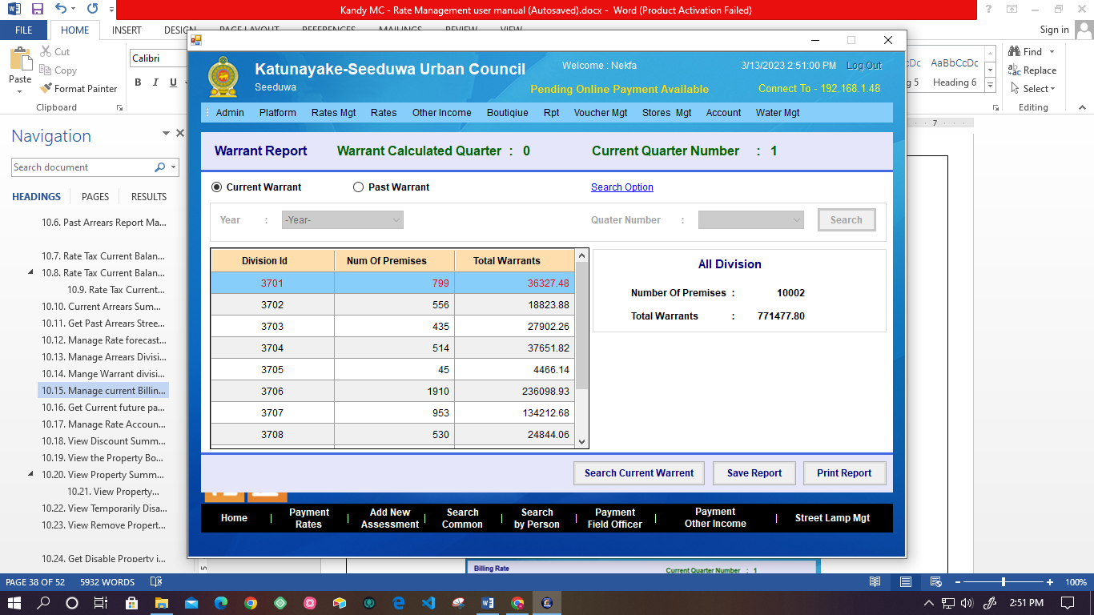

Figure - Warrant Report

* + System displays the current and past total warrant after the calculation.
  + Use can select the options current or past warrant.
  + System facilitates the user to search current warrant and save or print option.

## **Manage current Billing Rate division-wise Report**

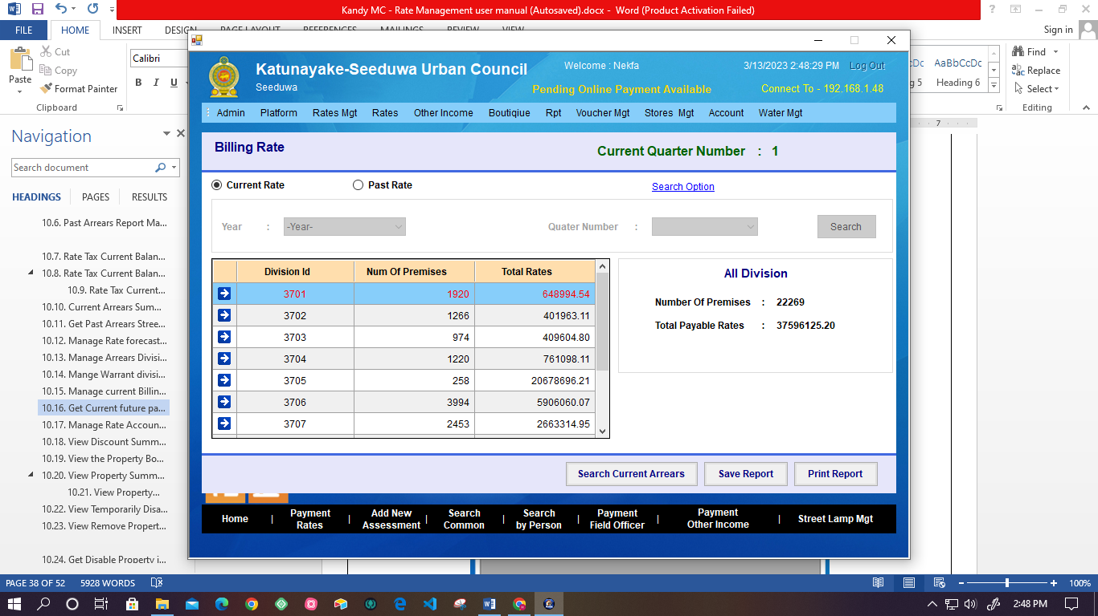

Figure - Billing rate

* System displays the rate for the current billed report details.
* For quarter open bill.
* User can search current arrears, save the report, and print the report.

## **Get Current future payment report**

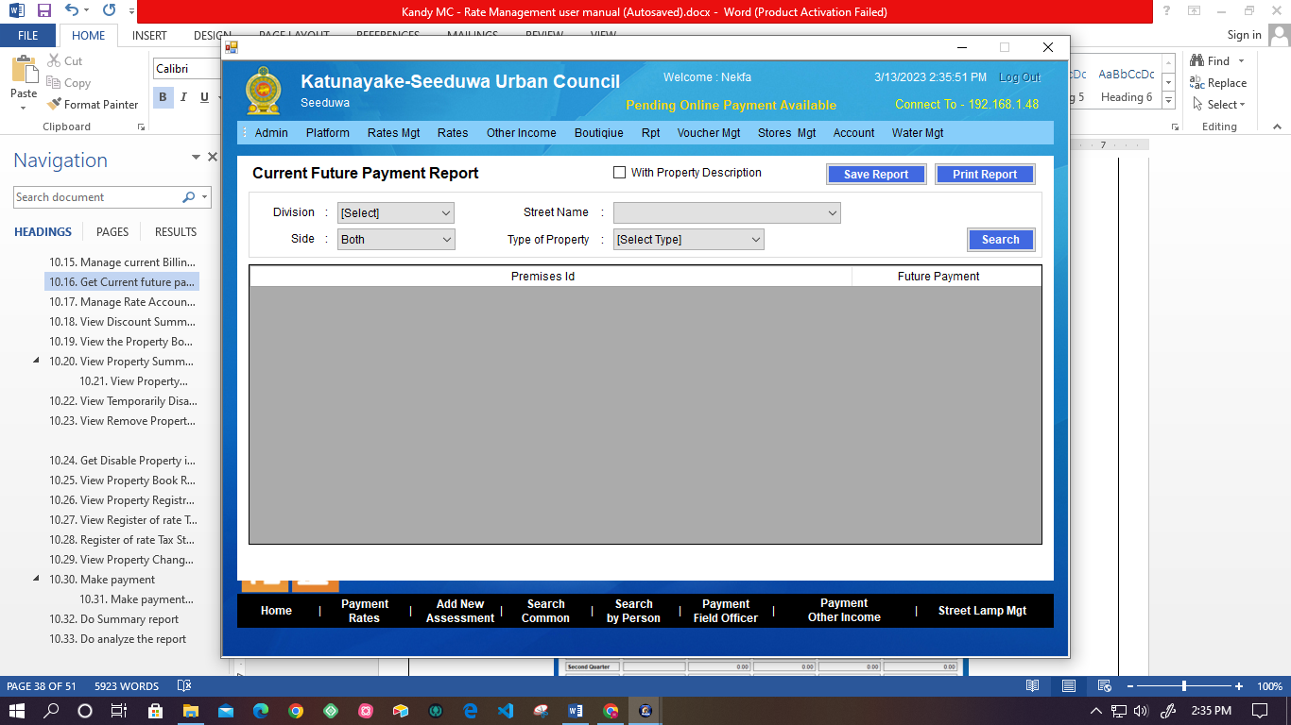

Figure -currant Future Payment report

* + System facilitates user to get details reports of current future payments.
  + User must select Division number, Side, Street Name, and Property Type.
  + System fetches the result from the database and displays it for the user.
  + User can save or print the report.

## **Manage Rate Accounting Listing Report**

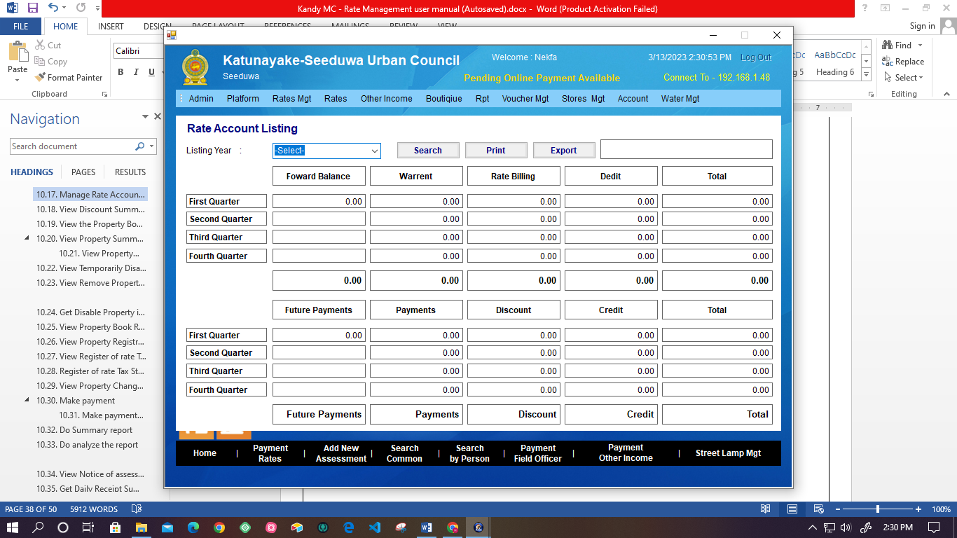

Figure -Rate Accounting Listing

* + - * System facilitates the user to list the rate account selected by the year.
      * System displays the total amount of the follows in each quarter.
* Forward Balance
* Warrant
* Rate Billing
* Debit
* Future payment
* Payments
* Discount
* Credit
  + - * User can search, export, and print the rate, Account List.

## **View Discount Summary Report**

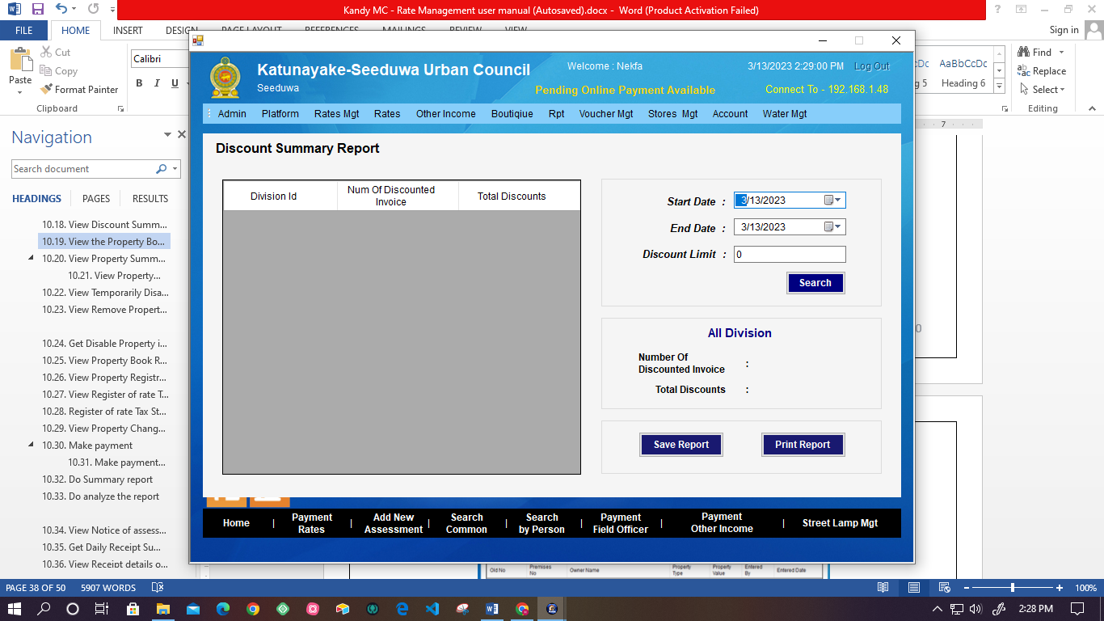

Figure - Discount Summary report

* User can get the Discount Summary Report by searching the Start Date, End Date, and Discount Limit.
* Also system displays the Number of Discount Invoices and Total Discounts.
* System facilitates the user to print or save the summary report.

## **View the Property Book Report**

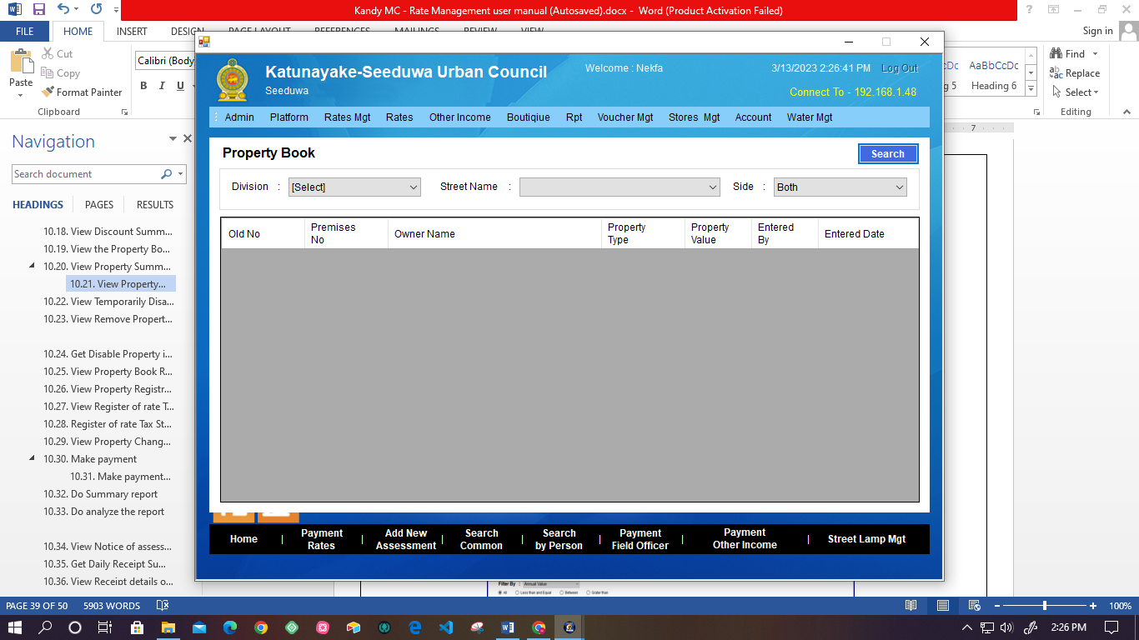

Figure - Property Book

* User can search the Property Book by searching the Division, Side, and Street Name.
* User can Export, Print, and View the report.

## **View Property Summary Report division wise**

Figure - Property summary report - Division wise

* + - * System facilitates the user to get the Property Summary Report division-wise by searching the Division.
      * System facilitates the user to Export, Print, and View the report.

## **View Property Annual Value Report**

Figure - Property Annual Value report

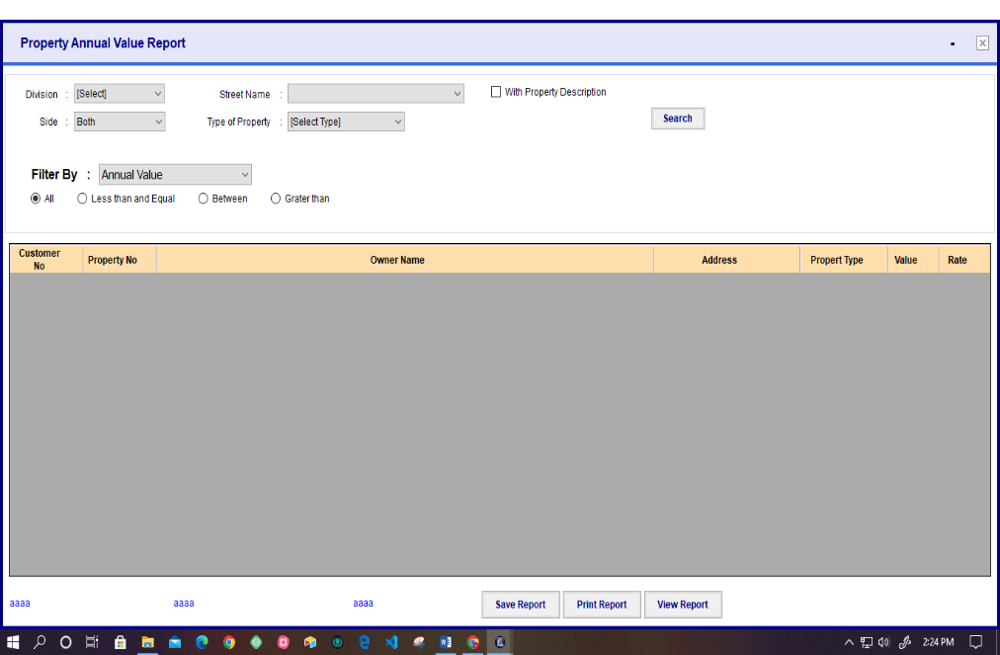

* User can search details report of the Property Annual Value Report using division, street, side, type of property
* Annual value can filter less than, greater than, and between.
* Also, user can save, print, and view the report

## **View Temporarily Disabled Property Value Report**

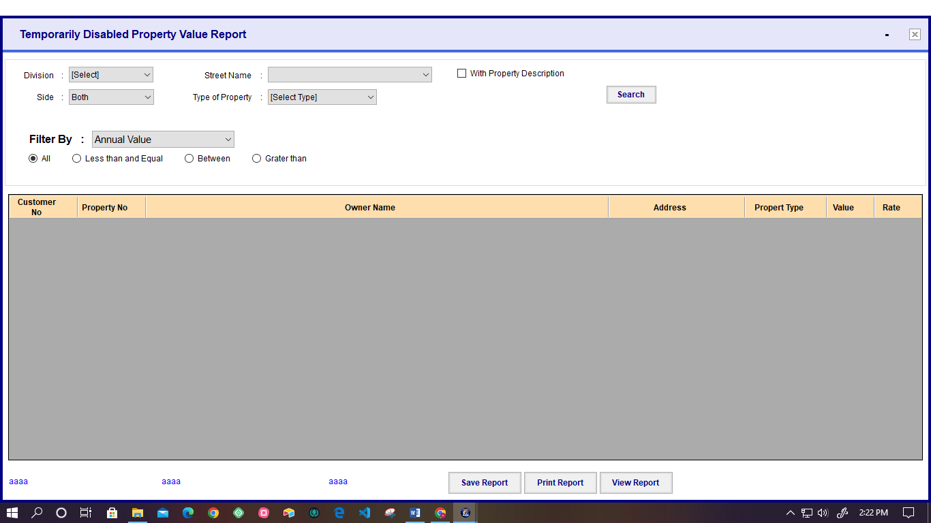

Figure - Temporary disable property report

* User can get the Temporary Disable Property Value Report by searching using division, street, side, type of property
* User can get the report result less than, greater than, between wise the Annual report.
* Also user can save, Print, and View the Temporarily Disable Property Value Report.

## **View Remove Property in duration Report**

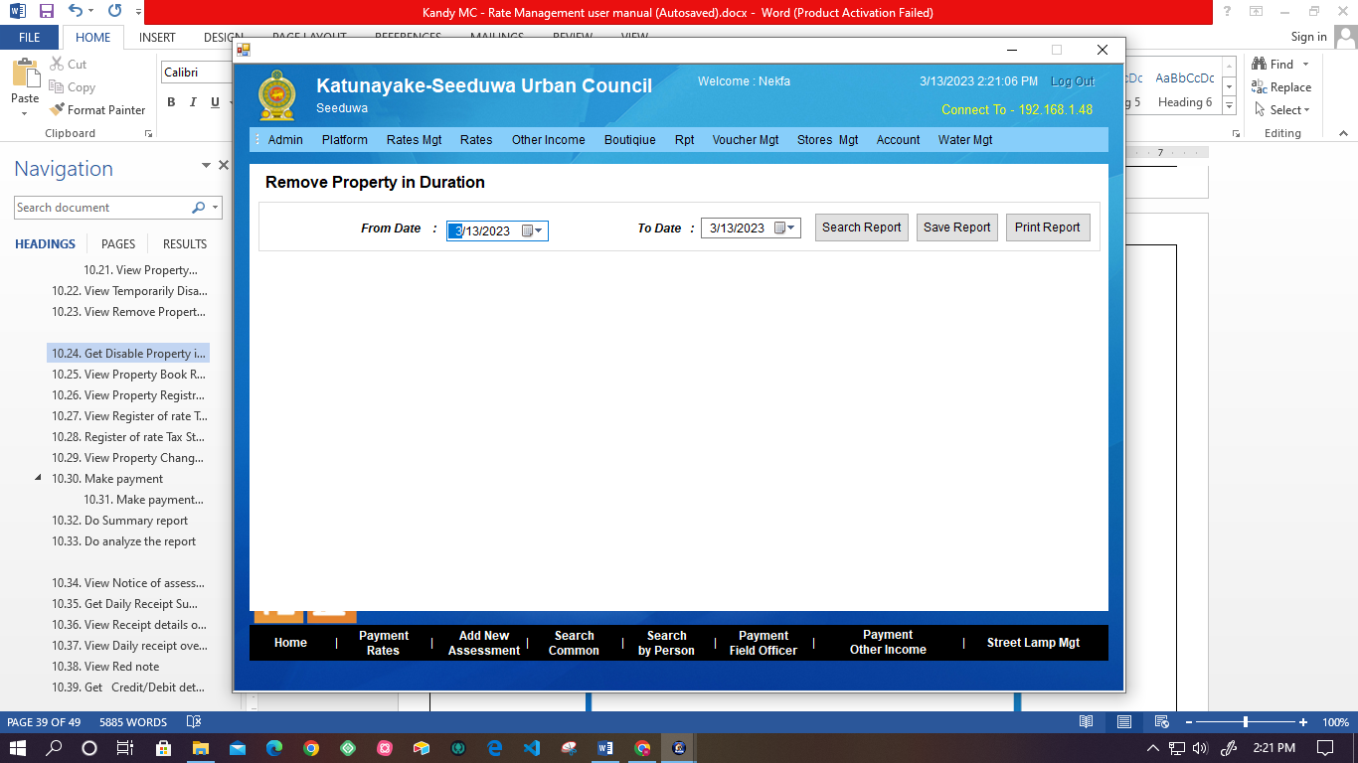

Figure - Remove property in duration

* User can search the report of Remove property in time duration.
* Also system facilitates the user to select a particular date duration using the calendar.
* If no result system displays the message “No records were found.”
* Also user can save or print the Remove Property in the duration Report.

## **Get Disable Property in duration Report**

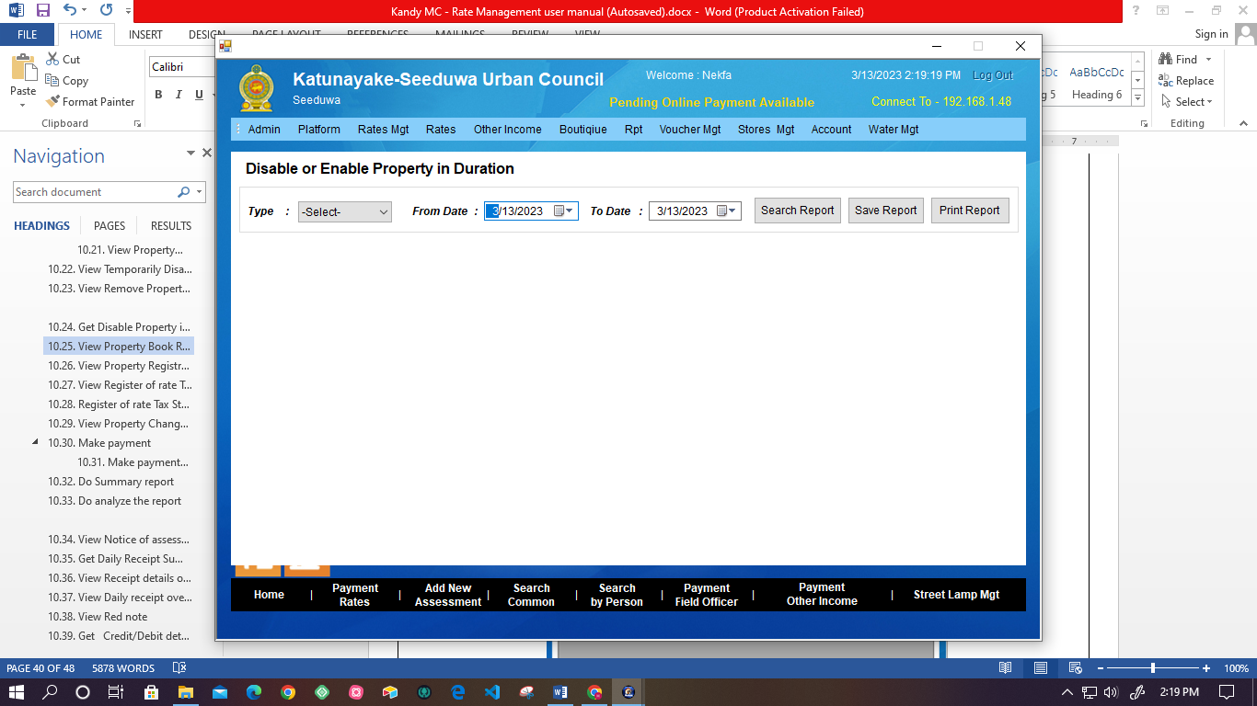

Figure - Enable Disable property in duration

* User can get the Disable property report in time duration by searching the Type (Enable or Disable), From Date to date.
* System facilitates the user to select date duration using the calendar.
* Also, Users can search, Save and print the report.

## **View Property Book Report**

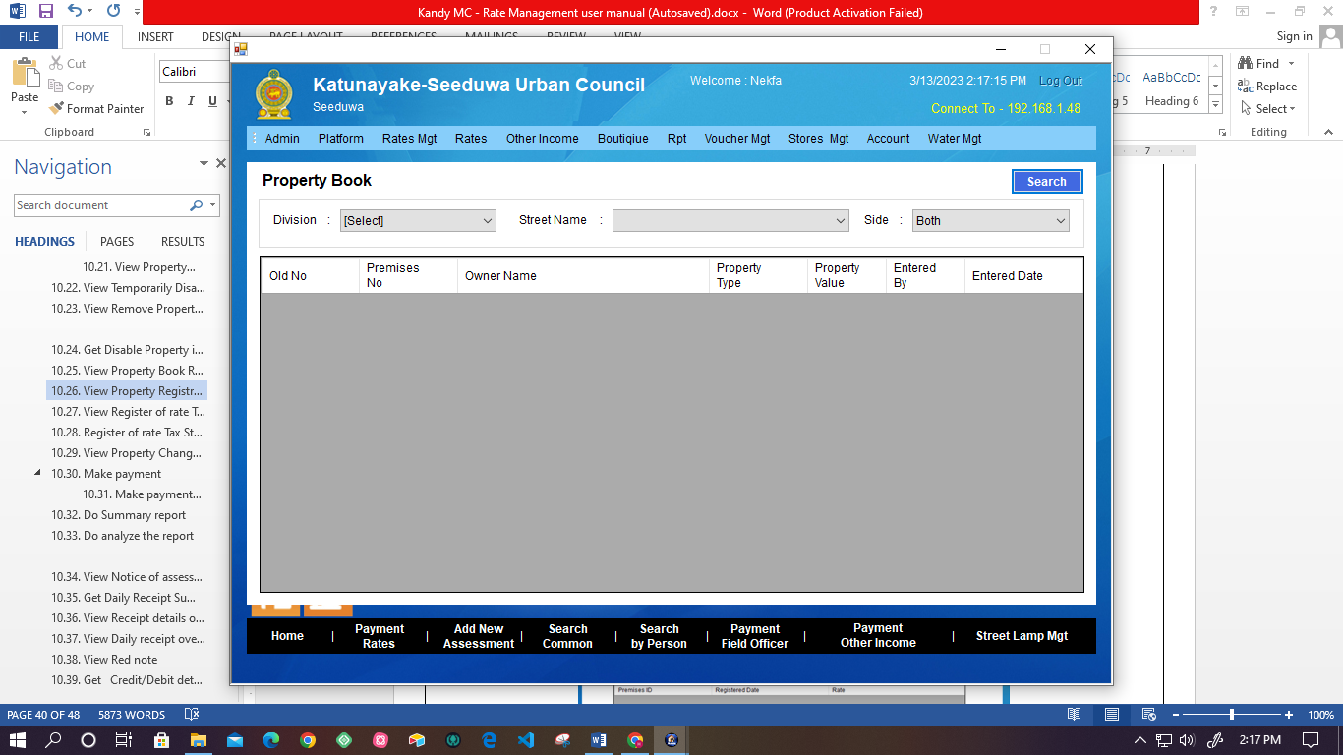

Figure - Property Book Report

* User can get the Property Book report by searching the Division, Street Name, and Side.

## **View Property Registration Report**

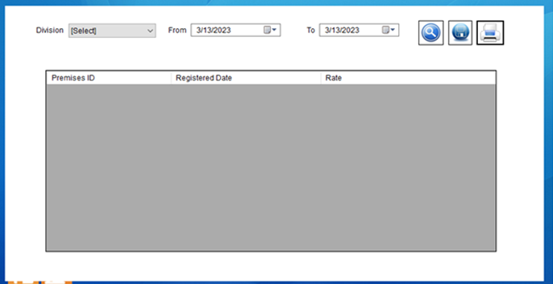

Figure - property Registration Report

* User can get the Property Registration Report by searching the Division and time duration.
* Also system gives the option to the user to Search, Print, and Save the report.

## **View Register of rate Tax**

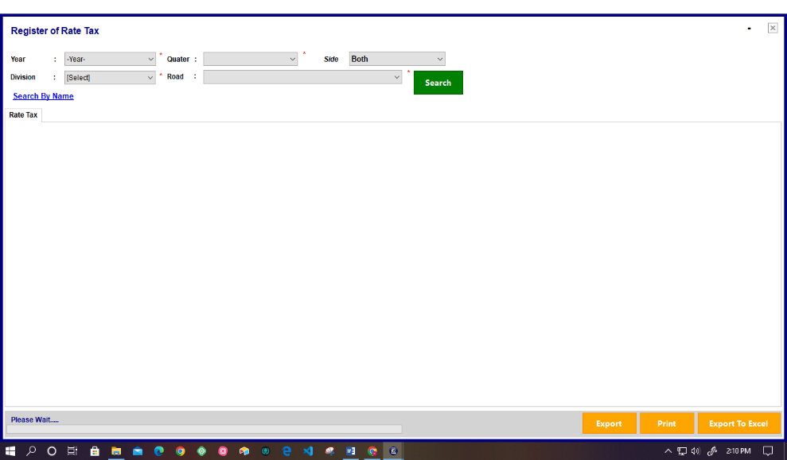

Figure - Register of Rate Tax

* + User can get the report of Register of Rate Tax.
  + Following details are required to search the report details.
  + Year
  + Quarter
  + Division
  + Rate
  + Also user can get the details by searching by the Owner’s Name.
  + User can Export, print, and Export to an excel sheet of the report.

## **Register of rate Tax Street summary**

Figure -Rate Tax street summary

* System facilitates to the user to get details of Rate Tax Street summary report by searching division, year, and quarter
* Also user can export or print the report.

## **View Property Change Report**

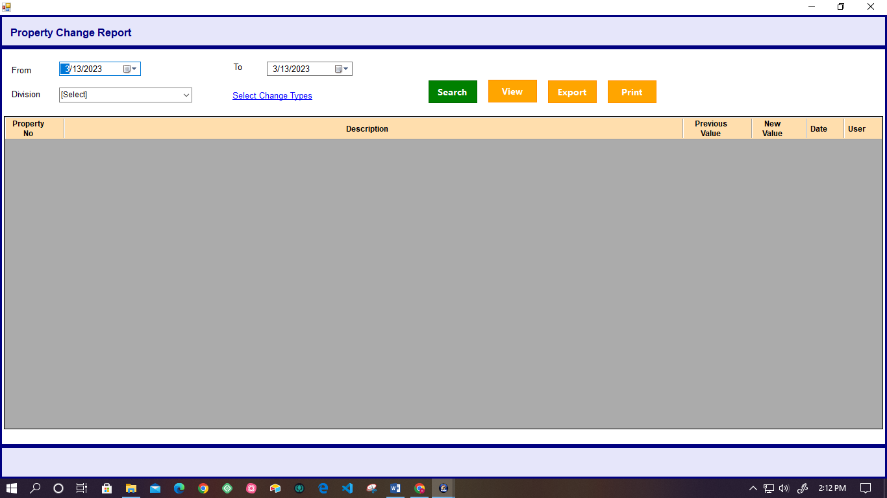

Figure - Property change report

* User can search the Property change report by searching the date duration and Division; also, the user can select the change types.
* Change type listed as follows.
* Owner name change
* Property Description change
* Property Type change
* Annual value change
* Year Rate change
* Property Number change
* User can View, Export, and Print the Property change Report.

## **Make payment**

* User can get the list of paid property searches by the Field office ID.

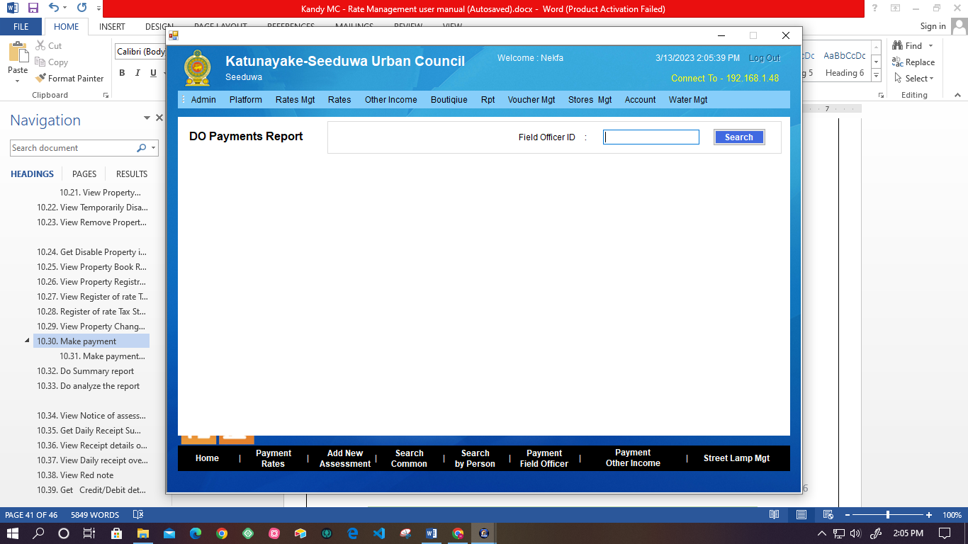

Figure -Do Pavement

## **Make payments for the duration**

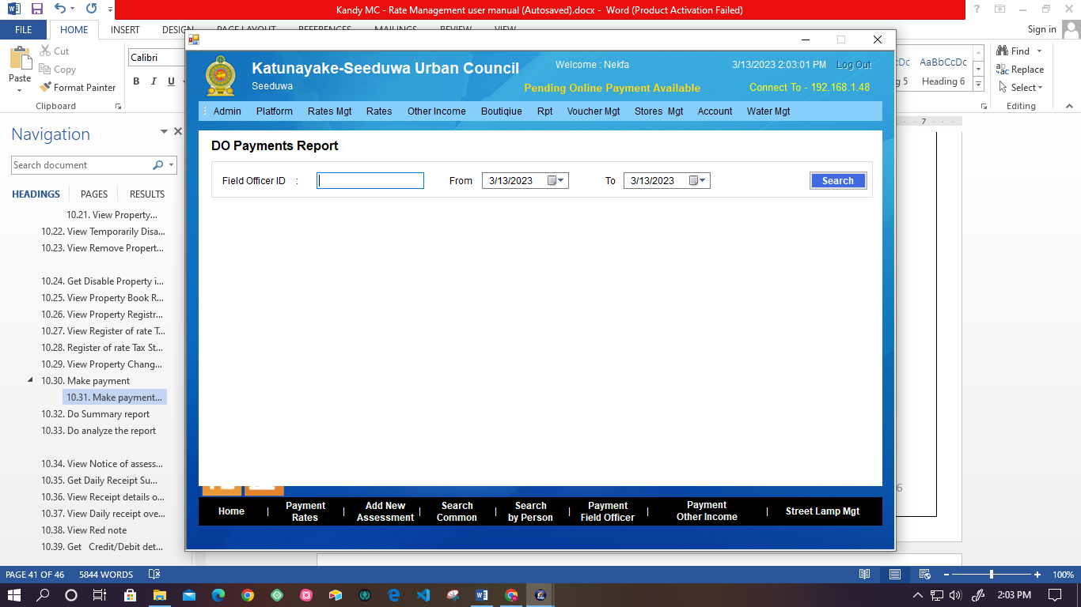

Figure - Do payment report

* User can get the Do payments report by searching the Field office ID and selecting the time duration.

## **Do Summary report**

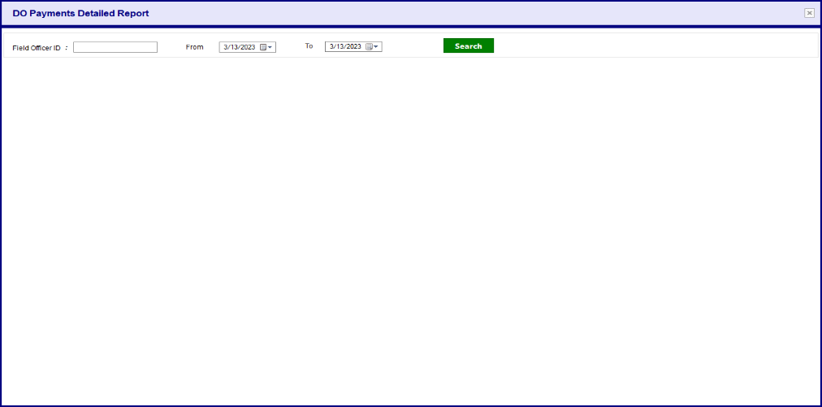

Figure - Do payment summary report

* System allows the user to get a summary report of payment details by searching the Field office ID and selecting the time duration.

## **Do analyze the report**

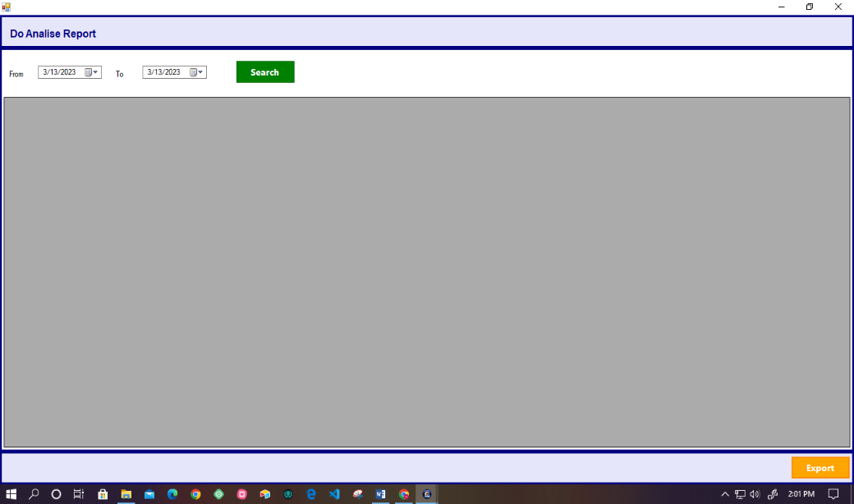

Figure -Do analyze the report

* System facilitates user to analyze report by searching the Field office ID and selecting the time duration.

## **View Notice of assessment**

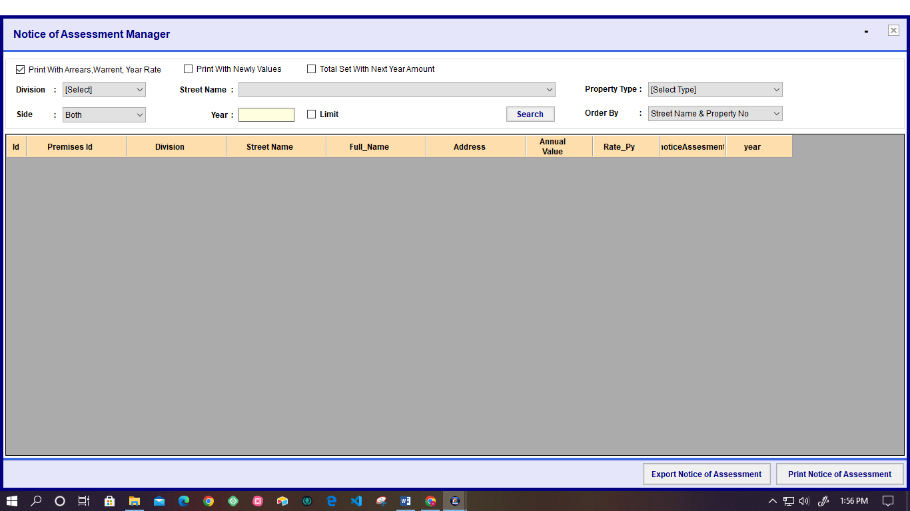

Figure -Notice of Assessment manager

* User can search the notice of Assessment by Division, Street name, Side, Year, and Property Type.
* User can Export and Print the Notice Assessment

## **Get the Daily Receipt Summary report**

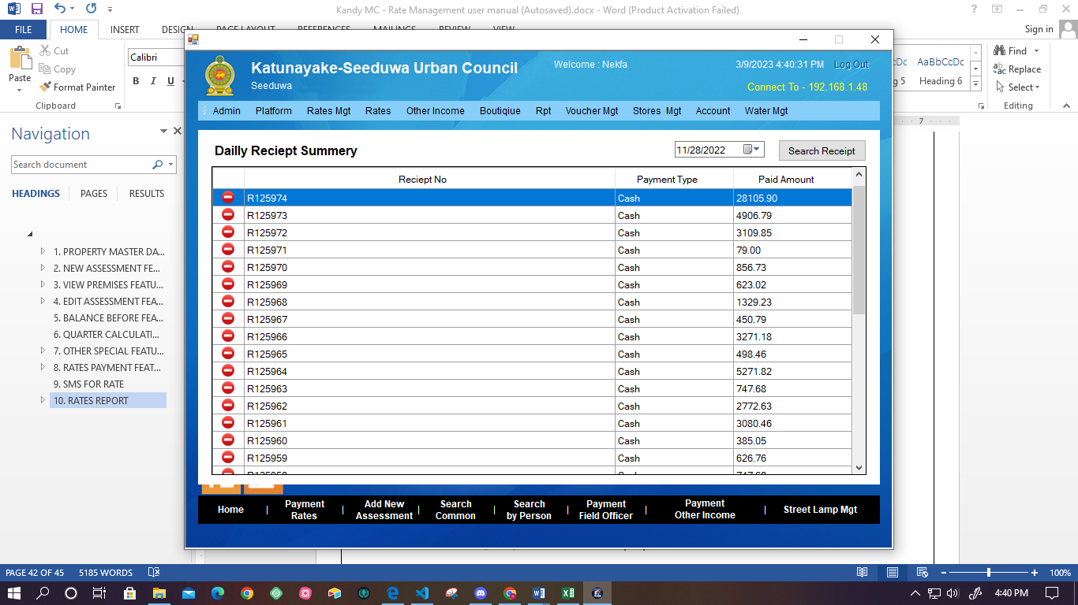

Figure - Daily receipt summary

* User can get the summary report of Daily receipts by selecting the Search by Date or Receipt Number option.
* Then, the system displays the details of the Daily Receipt summary.
* Also system facilitates the user to View, Export, and Print the report.

## **View Receipt details overview**

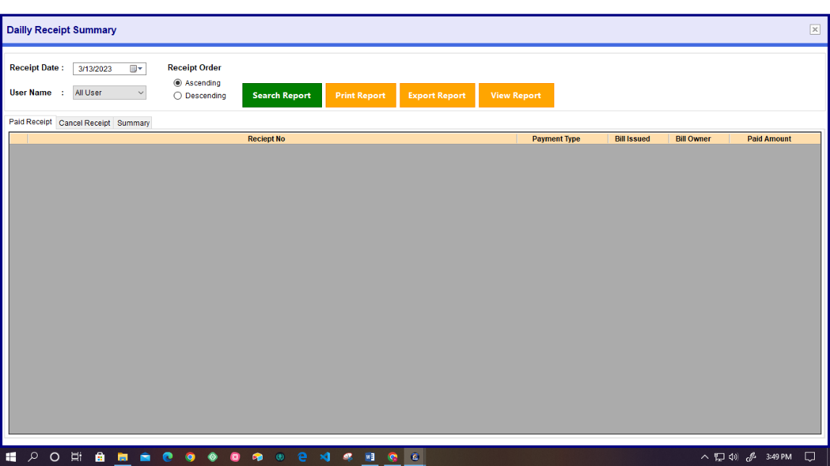

Figure 81- Daily Receipt Summary overview

* System facilitates users to get paid Receipts, Cancel Receipts, and Receipt summary reports.
* User has to select the time duration, Account Year, User, and Recipe Order (Ascending, Descending).
* User can Save, Print, and View the Summary Report.

## **View Daily receipt overview summary**

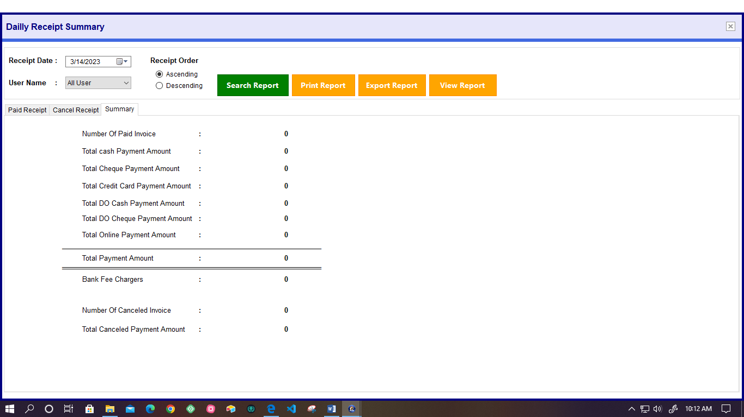

Figure - Daily receipt over view summary

* User can view the daily Receipt summary overview by clicking the “Summary” tab using this interface.

## **View Red note**

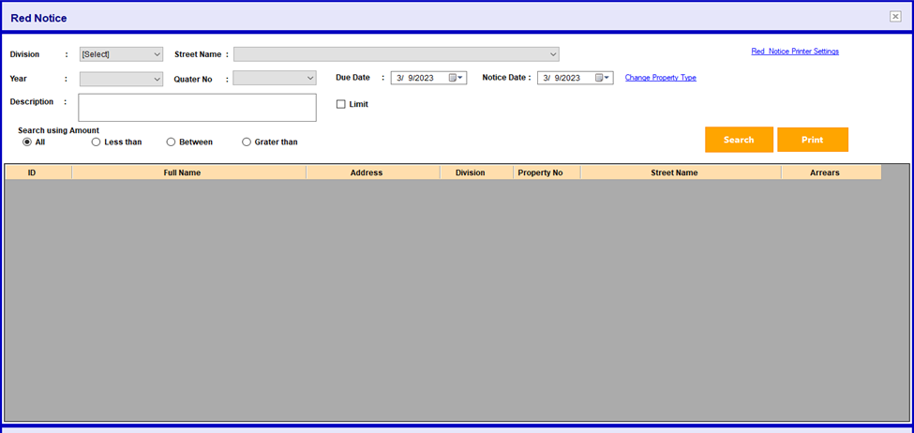

Figure - View red note

* User can search the Red Notice by selecting the following details.
* Division
* Street Name,
* Year
* Quarter
* Due Date
* Notice Date
* Amount (Has given the option select to All, Less than, Greater than, between)
* Also, user can change the property type.
* User can direct into the print setting by clicking the “Red Notice Printer Settings.”

## **Get Credit/Debit details**

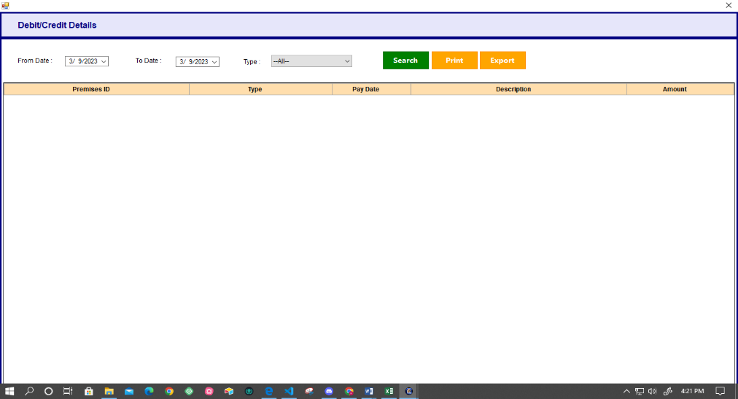

Figure - Credit/ Debit Details

* System facilitates to the user get details of credit and debit details report by selecting the “From date”, “To date” and “Type”.
* Also, the user can search, export, and print the details report of credit and Debit.

## **Terminated Accounts**

* System should facilitate to filter the check of return from the terminated accounts and quarter report.
* User should be get report according to the received discount.
* User should be to get total as following.
* From amount of Arrears
* From year (billing)
* From warrant
* From Forward balance